Mobility Fits

Weihsueh Chiu

6/20/2020

## Mobility data

Each mobility dataset for each state is Fit to Weibull+linear model, where the Weibull represents the process of sheltering in place, and linear represents the re-opening phase. The model is formulated as follows:

Here represents the baseline (pre-pandemic) value, and the Weibull term has parameters , , and . The “reopening” term is 0 prior to , linear between and , and constant at a value of after that, and made continuous by approximating the Heaviside function by a logistic function. The reopening time is defined as days after , and the maximum reopening amount happens days after that. The time-dependence of both the sheltering phase and reopening phase are represented by functions with a range between 0 and 1.

### Unacast

## Warning in nls.lm(par = start, fn = FCT, jac = jac, control = control, lower = lower, : lmdif: info = -1. Number of iterations has reached `maxiter' == 50.  
  
## Warning in nls.lm(par = start, fn = FCT, jac = jac, control = control, lower = lower, : lmdif: info = -1. Number of iterations has reached `maxiter' == 50.  
  
## Warning in nls.lm(par = start, fn = FCT, jac = jac, control = control, lower = lower, : lmdif: info = -1. Number of iterations has reached `maxiter' == 50.

## Warning: Removed 151 rows containing missing values (geom_vline).  
  
## Warning: Removed 151 rows containing missing values (geom_vline).  
  
## Warning: Removed 151 rows containing missing values (geom_vline).  
  
## Warning: Removed 151 rows containing missing values (geom_vline).

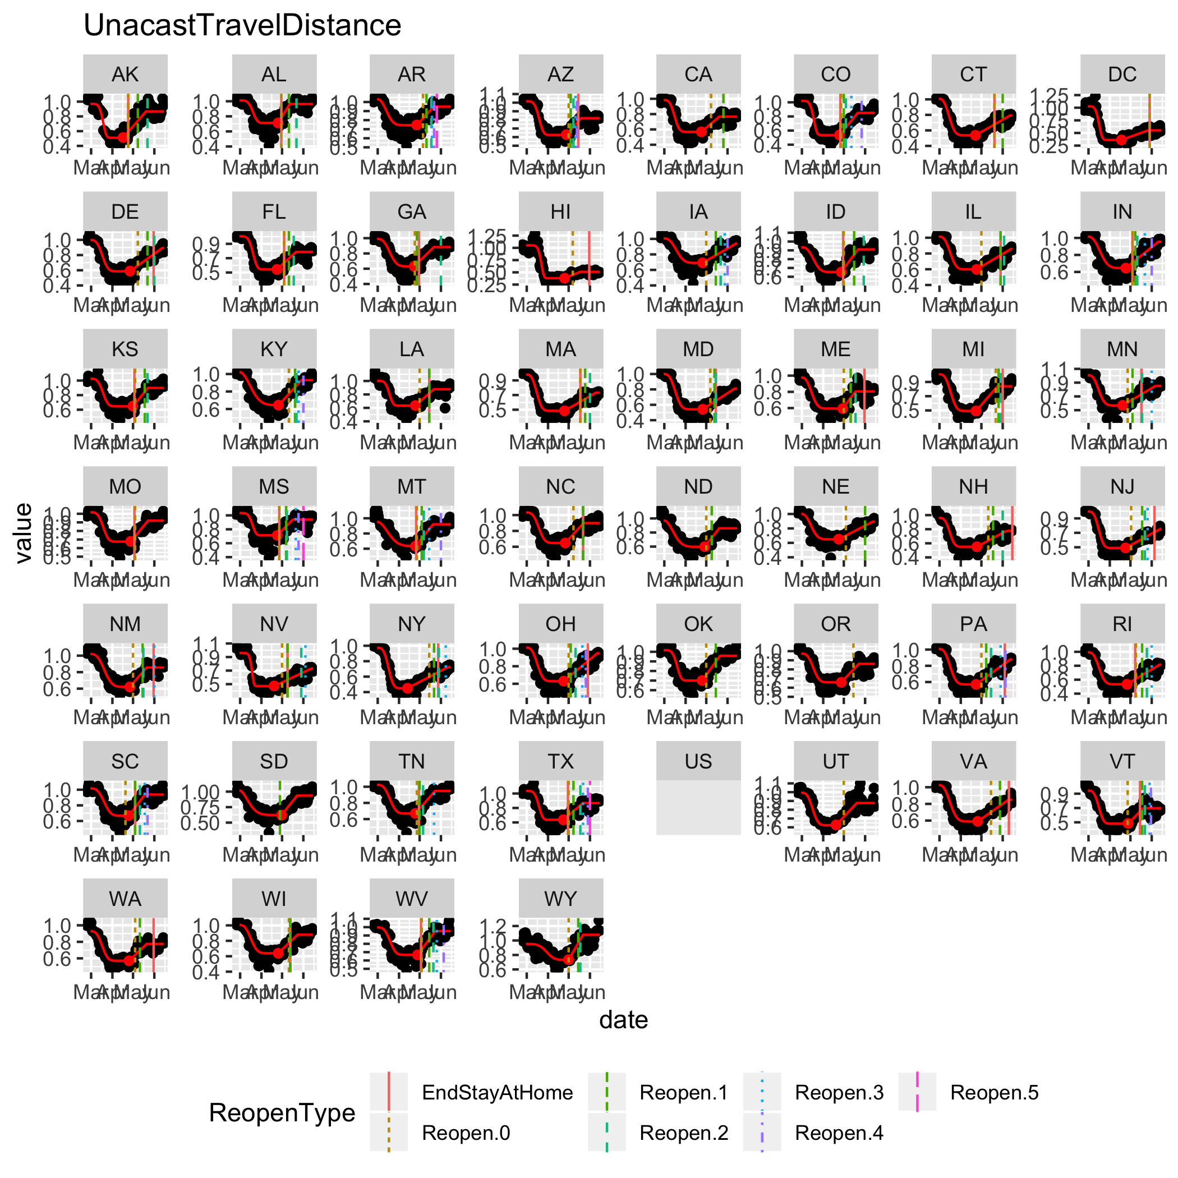

## Warning: Removed 151 rows containing missing values (geom_vline).

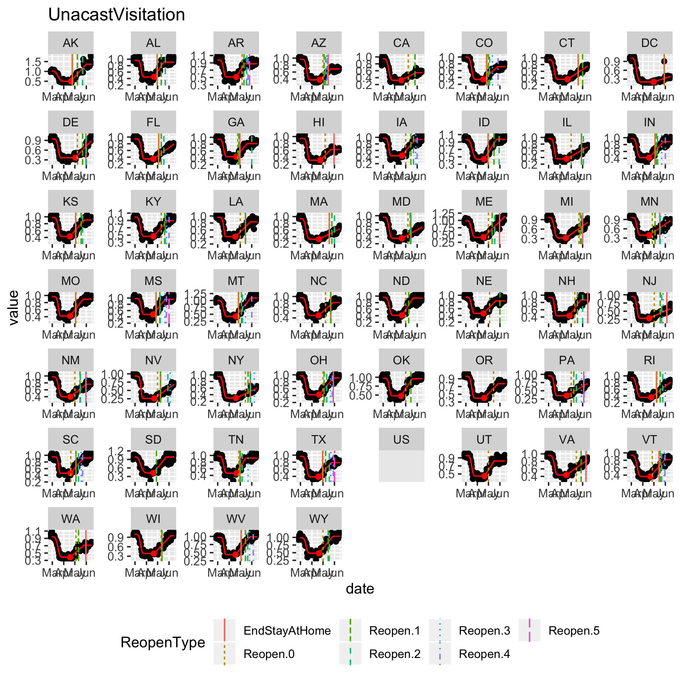

## Warning: Removed 151 rows containing missing values (geom_vline).

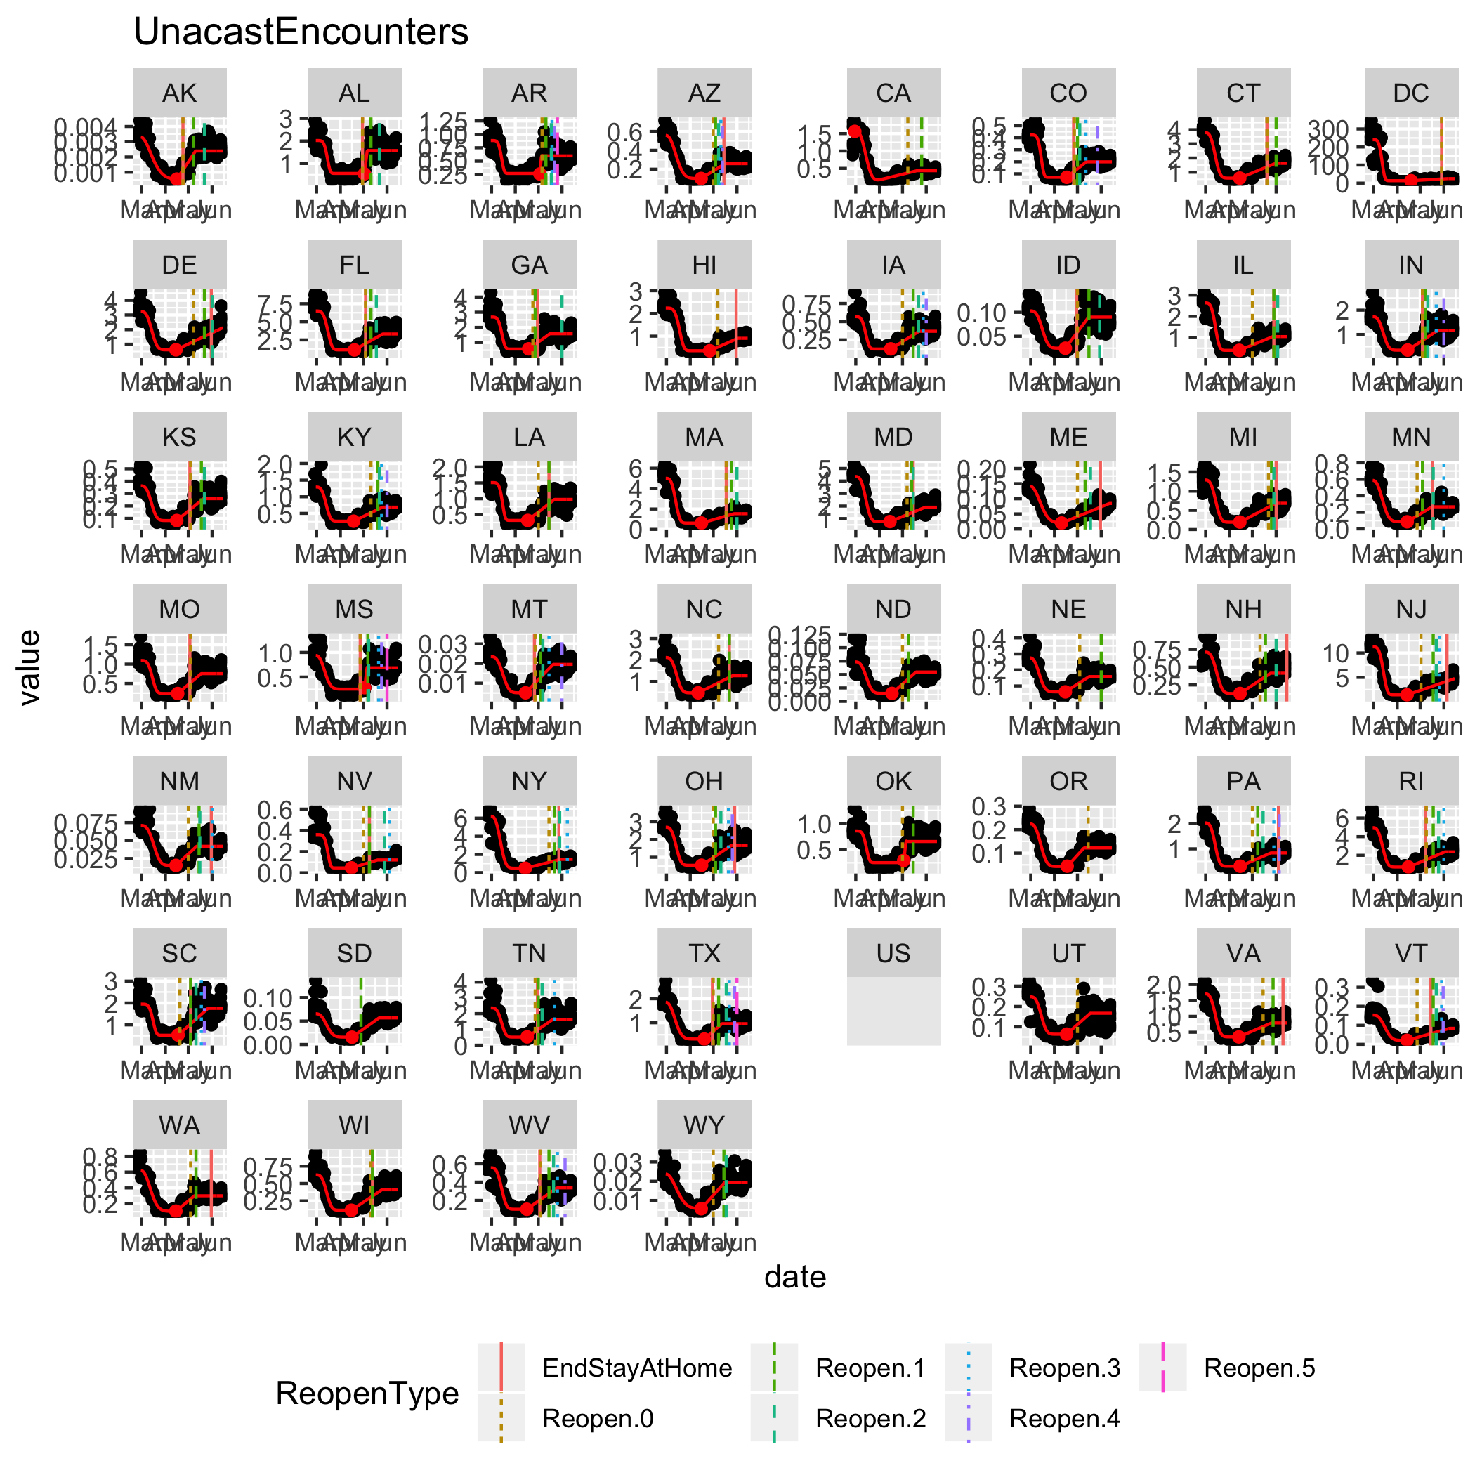

### Google

## Warning in nls.lm(par = start, fn = FCT, jac = jac, control = control, lower = lower, : lmdif: info = -1. Number of iterations has reached `maxiter' == 50.

## Warning: Removed 151 rows containing missing values (geom_vline).  
  
## Warning: Removed 151 rows containing missing values (geom_vline).  
  
## Warning: Removed 151 rows containing missing values (geom_vline).  
  
## Warning: Removed 151 rows containing missing values (geom_vline).  
  
## Warning: Removed 151 rows containing missing values (geom_vline).

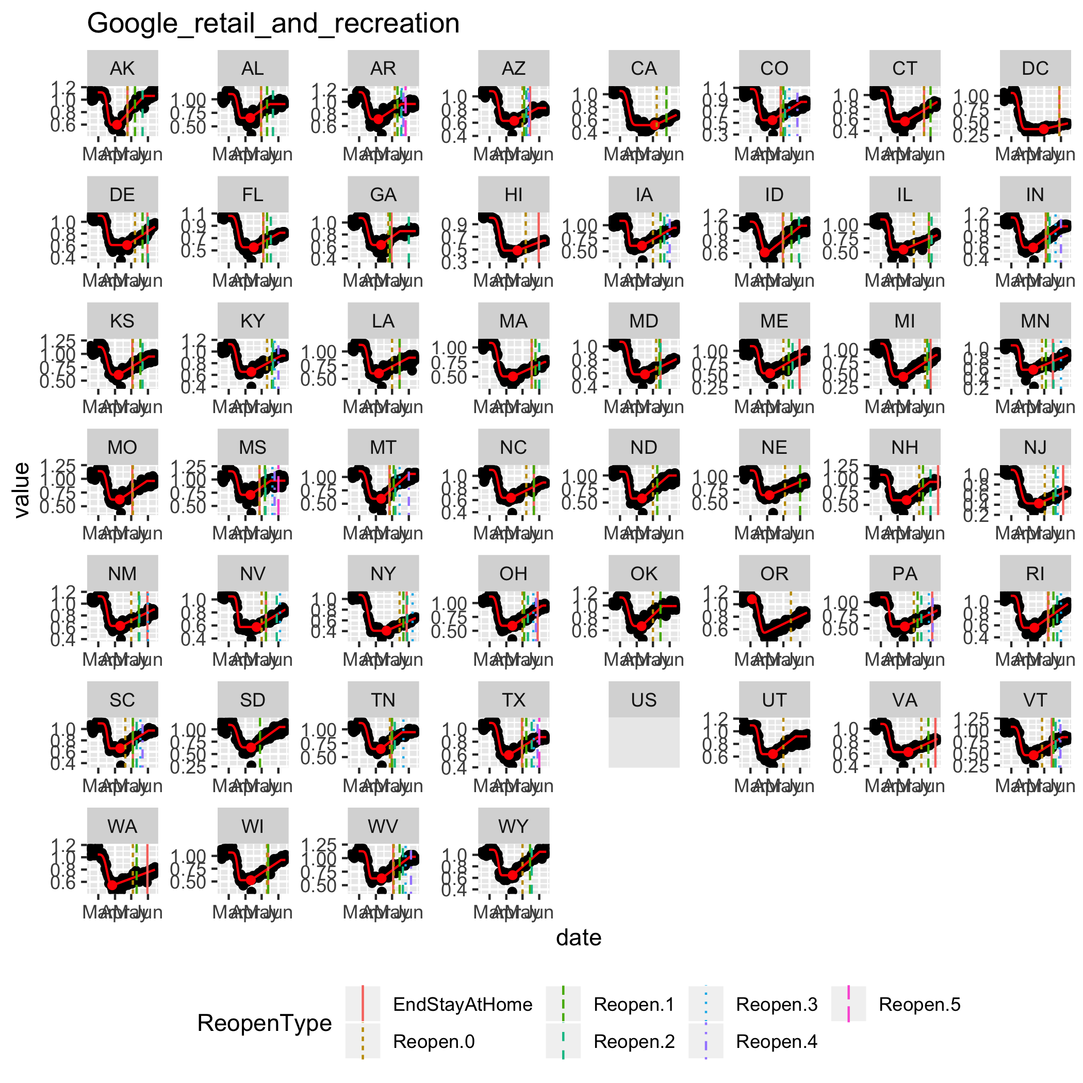

## Warning: Removed 151 rows containing missing values (geom_vline).

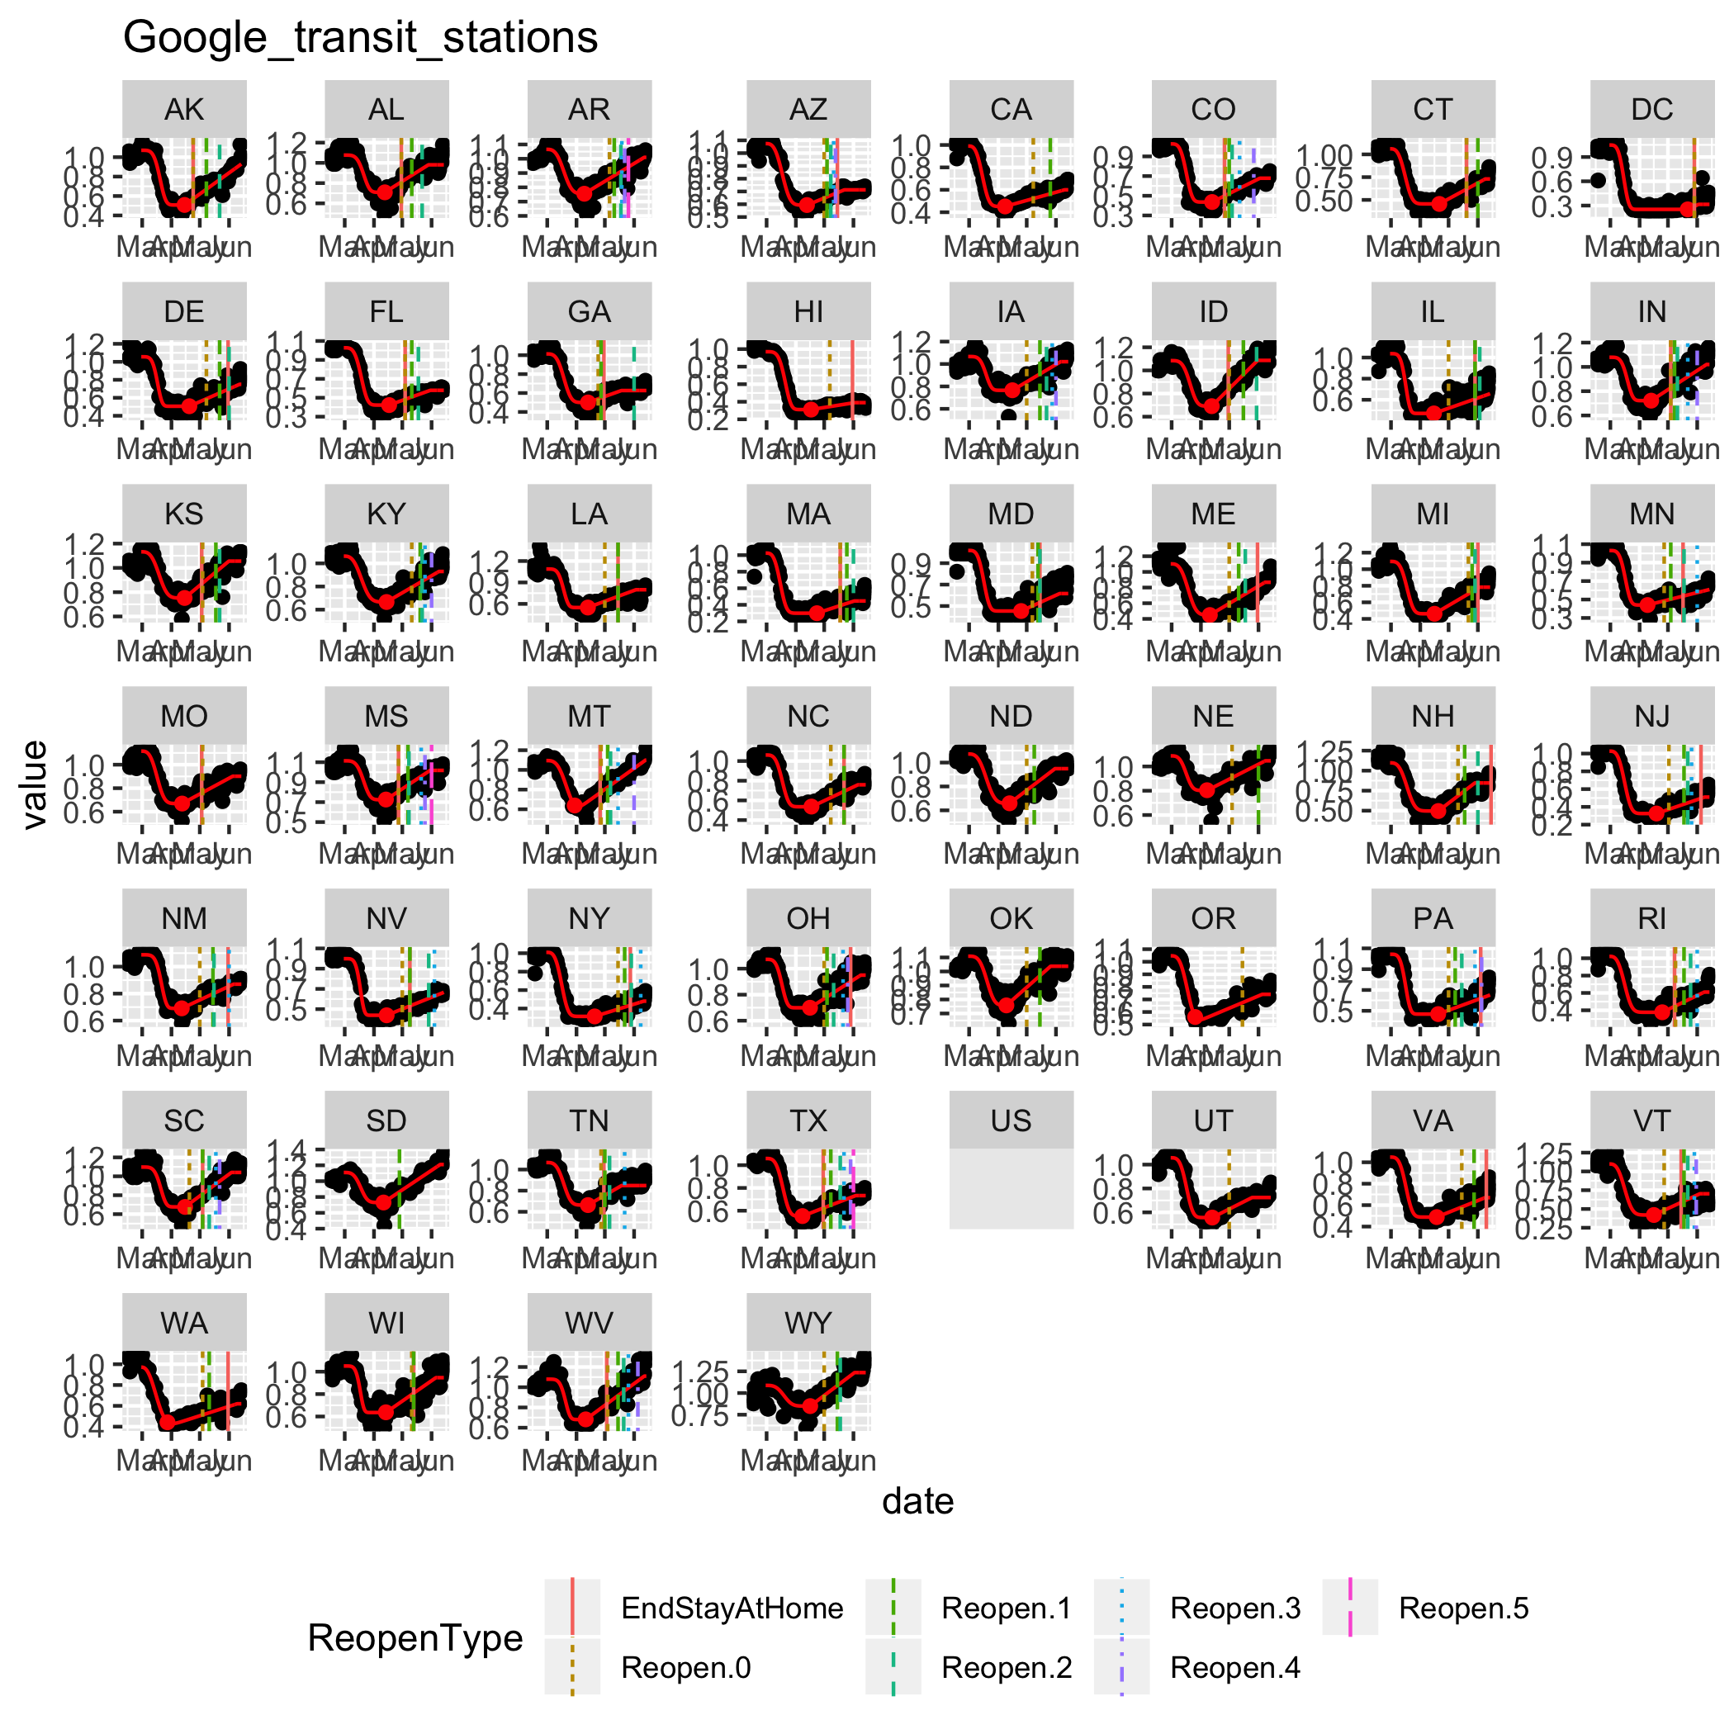

## Warning: Removed 151 rows containing missing values (geom_vline).

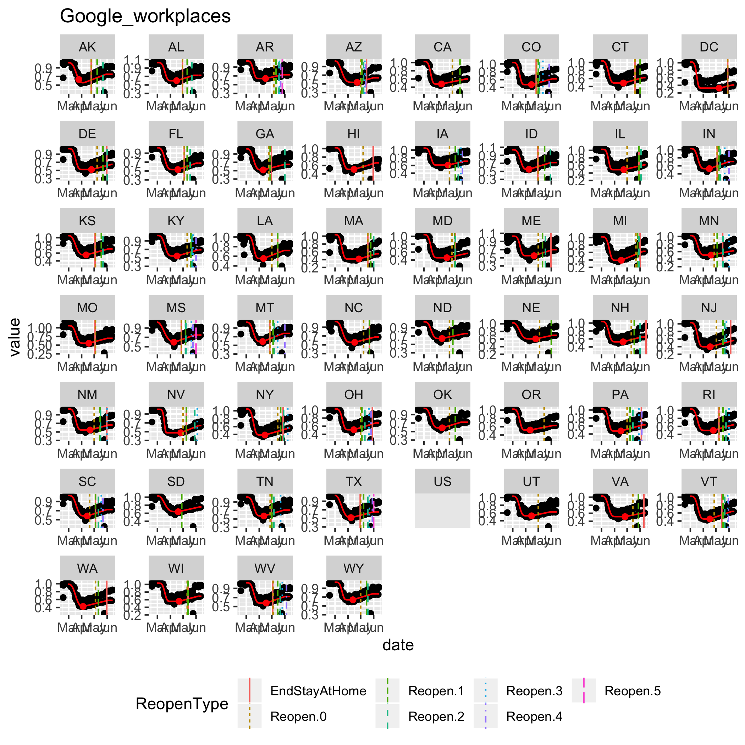

## Warning: Removed 151 rows containing missing values (geom_vline).

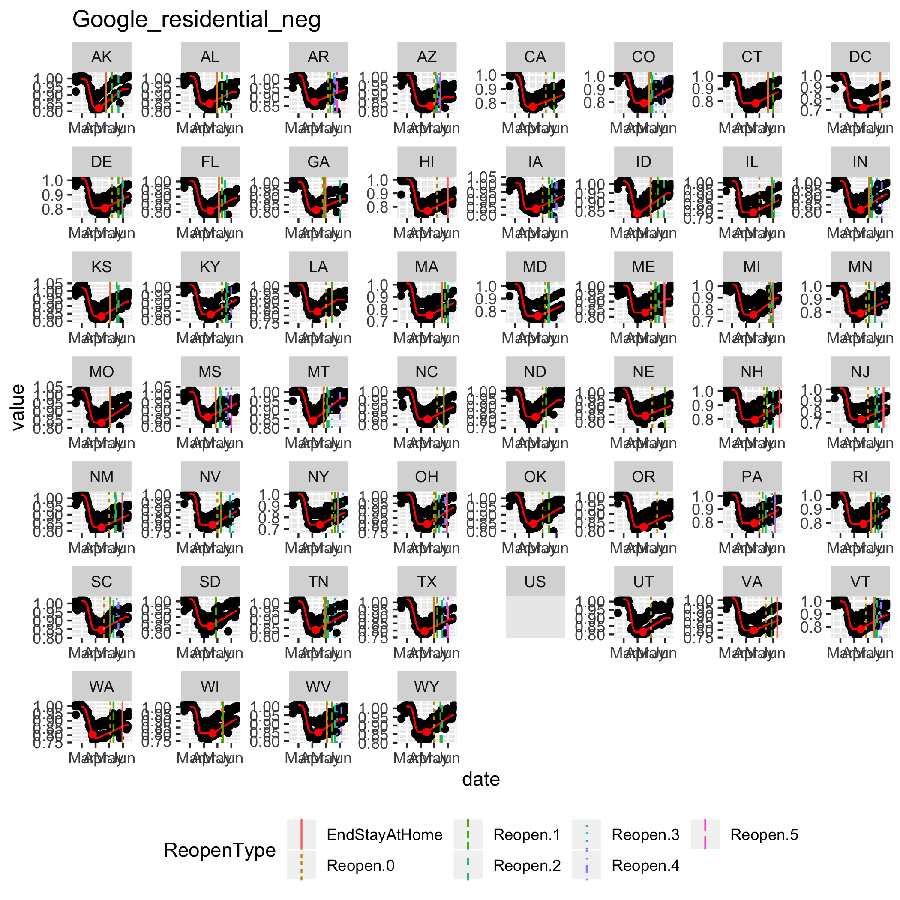

### OpenTable

If missing, substitute US country-wide value.

## Warning in melt.data.table(as.data.table(odata), id.vars = 1:2, stringsAsFactors  
## = FALSE): 'measure.vars' [2020-2-18, 2020-2-19, 2020-2-20, 2020-2-21, ...] are  
## not all of the same type. By order of hierarchy, the molten data value column  
## will be of type 'double'. All measure variables not of type 'double' will be  
## coerced too. Check DETAILS in ?melt.data.table for more on coercion.

## Warning: Removed 151 rows containing missing values (geom_vline).  
  
## Warning: Removed 151 rows containing missing values (geom_vline).

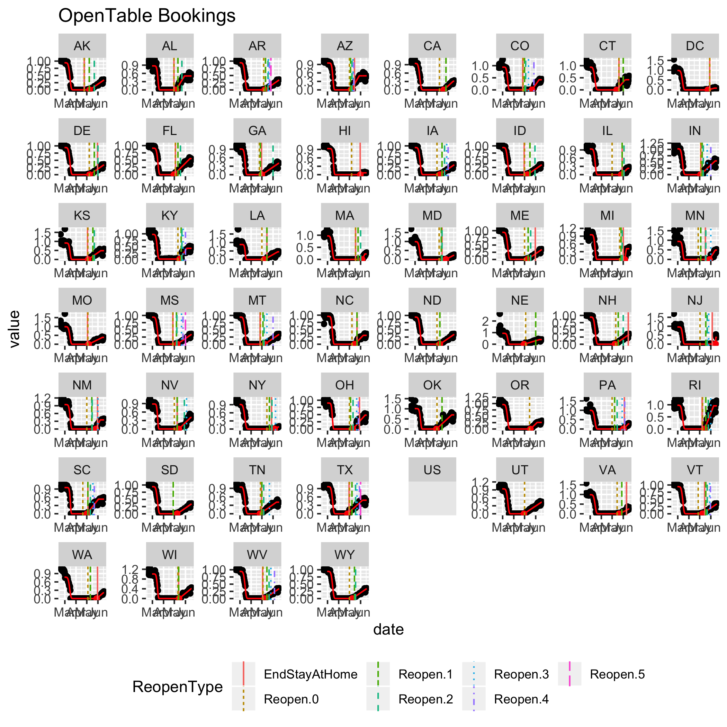

## Summary by state

vars <- c("date","State.Abbr","numDate","variable","value","fit",  
 "ys","thetamin","tautheta","ntheta",  
 "taus","taur","rmax")  
allfits.df <- rbind(  
 ufits.df[,..vars],  
 gfits.df[,..vars],  
 ofits.df[,..vars]  
)  
allfits.df$normfit <- allfits.df$fit/allfits.df$ys  
allfits.df$scalefit <- (allfits.df$fit/allfits.df$ys - allfits.df$thetamin)/(1-allfits.df$thetamin)  
allfits.df$treopen <- 60+allfits.df$tautheta+allfits.df$taus  
names(allfits.df)[names(allfits.df)=="variable"]<-"MobilityMetric"  
allfits.df$AbbrMobMet<-abbreviate(gsub("_","",  
 allfits.df$MobilityMetric),  
 minlength=10)  
write.csv(allfits.df,file="MobilityFits.csv",row.names=FALSE)  
  
allfitstmp.df<-allfits.df  
allfitstmp.df$ys <- log10(allfitstmp.df$ys)  
names(allfitstmp.df)[names(allfitstmp.df)=="ys"]<-"log10ys"  
fitparms.df <- melt(as.data.table(  
 allfitstmp.df[,c("date","State.Abbr","MobilityMetric","AbbrMobMet",  
 "log10ys","thetamin","tautheta","ntheta",  
 "taus","taur","rmax","treopen")]),  
 id.vars=1:4)  
fitparms.df <- subset(fitparms.df,date==as.Date(fit0datemax,origin=datezero))  
write.csv(fitparms.df,file="MobilityParms.csv",row.names=FALSE)  
  
pdf("Mobility.pdf",height=8.5,width=11)  
for (statenow in unique(as.character(allfits.df$State.Abbr))) {  
 p<-ggplot(subset(allfits.df,State.Abbr==statenow))+  
 geom_point(aes(x=date,y=value))+  
 geom_line(aes(x=date,y=fit),color="red",  
 data=subset(allfits.df,State.Abbr==statenow))+  
 geom_vline(aes(xintercept=value,linetype=ReopenType,  
 color=ReopenType),  
 data=subset(reopendat.df,State.Abbr==statenow))+  
 geom_point(aes(x=as.Date(treopen,origin=datezero),  
 y=fit),color="red",  
 data=subset(allfits.df[allfits.df$numDate==  
 round(allfits.df$treopen),],  
 State.Abbr==statenow))+  
 facet_wrap(~MobilityMetric,scales="free")+  
 theme(legend.position = "bottom")  
 print(p+ggtitle(statenow))  
 pp <- ggplot(subset(fitparms.df,State.Abbr==statenow))+  
 geom_boxplot(aes(y=value),outlier.color="grey")+  
 geom_point(aes(x=AbbrMobMet,y=value))+  
 facet_wrap(~variable,scales="free")+coord_flip()  
 print(pp)  
}

## Warning: Removed 24 rows containing missing values (geom_vline).  
  
## Warning: Removed 24 rows containing missing values (geom_vline).

## Warning: Removed 8 rows containing missing values (geom_vline).  
  
## Warning: Removed 8 rows containing missing values (geom_vline).

## Warning: Removed 32 rows containing missing values (geom_vline).

## Warning: Removed 8 rows containing missing values (geom_vline).

## Warning: Removed 32 rows containing missing values (geom_vline).

## Warning: Removed 24 rows containing missing values (geom_vline).

## Warning: Removed 40 rows containing missing values (geom_vline).

## Warning: Removed 24 rows containing missing values (geom_vline).  
  
## Warning: Removed 24 rows containing missing values (geom_vline).

## Warning: Removed 40 rows containing missing values (geom_vline).

## Warning: Removed 24 rows containing missing values (geom_vline).  
  
## Warning: Removed 24 rows containing missing values (geom_vline).

## Warning: Removed 8 rows containing missing values (geom_vline).

## Warning: Removed 16 rows containing missing values (geom_vline).

## Warning: Removed 24 rows containing missing values (geom_vline).

## Warning: Removed 32 rows containing missing values (geom_vline).

## Warning: Removed 24 rows containing missing values (geom_vline).  
  
## Warning: Removed 24 rows containing missing values (geom_vline).  
  
## Warning: Removed 24 rows containing missing values (geom_vline).  
  
## Warning: Removed 24 rows containing missing values (geom_vline).

## Warning: Removed 16 rows containing missing values (geom_vline).

## Warning: Removed 40 rows containing missing values (geom_vline).

## Warning: Removed 8 rows containing missing values (geom_vline).

## Warning: Removed 40 rows containing missing values (geom_vline).

## Warning: Removed 16 rows containing missing values (geom_vline).

## Warning: Removed 24 rows containing missing values (geom_vline).

## Warning: Removed 16 rows containing missing values (geom_vline).  
  
## Warning: Removed 16 rows containing missing values (geom_vline).  
  
## Warning: Removed 16 rows containing missing values (geom_vline).

## Warning: Removed 32 rows containing missing values (geom_vline).

## Warning: Removed 40 rows containing missing values (geom_vline).

## Warning: Removed 8 rows containing missing values (geom_vline).

## Warning: Removed 40 rows containing missing values (geom_vline).  
  
## Warning: Removed 40 rows containing missing values (geom_vline).

## Warning: Removed 8 rows containing missing values (geom_vline).

## Warning: Removed 16 rows containing missing values (geom_vline).

## Warning: Removed 8 rows containing missing values (geom_vline).

## Warning: Removed 48 rows containing missing values (geom_vline).

## Warning: Removed 16 rows containing missing values (geom_vline).

## Warning: Removed 48 rows containing missing values (geom_vline).

## Warning: Removed 8 rows containing missing values (geom_vline).

## Warning: Removed 32 rows containing missing values (geom_vline).  
  
## Warning: Removed 32 rows containing missing values (geom_vline).

## Warning: Removed 8 rows containing missing values (geom_vline).

## Warning: Removed 32 rows containing missing values (geom_vline).  
  
## Warning: Removed 32 rows containing missing values (geom_vline).

dev.off()

## quartz_off_screen   
## 2

pdf("MobilityFitNorm.pdf",height=6,width=9)  
for (statenow in unique(as.character(allfits.df$State.Abbr))) {  
 p<-ggplot(subset(allfits.df,State.Abbr==statenow))+  
 geom_line(aes(x=date,y=normfit,color=MobilityMetric,  
 linetype=MobilityMetric),  
 data=subset(allfits.df,State.Abbr==statenow))+  
 geom_point(aes(x=as.Date(treopen,origin=datezero),  
 y=normfit),color="red",  
 data=subset(allfits.df[allfits.df$numDate==  
 round(allfits.df$treopen),],  
 State.Abbr==statenow))+  
 theme(legend.position = "bottom")  
 print(p+ggtitle(statenow))  
}  
dev.off()

## quartz_off_screen   
## 2

pdf("MobilityFitScale.pdf",height=6,width=9)  
for (statenow in unique(as.character(allfits.df$State.Abbr))) {  
 p<-ggplot(subset(allfits.df,State.Abbr==statenow))+  
 geom_line(aes(x=date,y=scalefit,color=MobilityMetric,  
 linetype=MobilityMetric),  
 data=subset(allfits.df,State.Abbr==statenow))+  
 geom_point(aes(x=as.Date(treopen,origin=datezero),  
 y=scalefit),color="red",  
 data=subset(allfits.df[allfits.df$numDate==  
 round(allfits.df$treopen),],  
 State.Abbr==statenow))+  
 theme(legend.position = "bottom")  
 print(p+ggtitle(statenow))  
}  
dev.off()

## quartz_off_screen   
## 2

## Discussion

The Weibull+linear parameterization gives an adequate fit to the time-dependence for all the mobility data sources investigated. Although clearly the linear increase cannot continue indefinitely, at least through the beginning of June, it is fairly representative.

Of note is that for all mobility data sources except for restaurant reservations, the linear increase began *prior* to the first re-opening milestone. Therefore, it is not necessarily reliable to rely upon announced re-opening dates to represent when changes in transmission rates may occur.

fitm<-as.data.frame(aggregate(value~variable*State.Abbr,data=fitparms.df,mean))  
names(fitm)<-c("variable","State.Abbr","value.mean")  
fitsd<-as.data.frame(aggregate(value~variable*State.Abbr,data=fitparms.df,sd))  
names(fitsd)<-c("variable","State.Abbr","value.sd")  
fitq<-aggregate(value~variable*State.Abbr,data=fitparms.df,quantile,  
 prob=c(0,0.025,0.25,0.5,0.75,0.975,1),simplify=TRUE)  
fitsum<-cbind(fitm,fitsd,fitq)  
fitsum<-fitsum[,-c(4:5,7:8)]  
print(fitsum)

## variable State.Abbr value.mean value.sd value.0% value.2.5%  
## 1 log10ys AK -0.303427861 0.87977439 -2.479996e+00 -2.050573e+00  
## 2 thetamin AK 0.438644122 0.25047135 1.897177e-03 2.970740e-02  
## 3 tautheta AK 19.545734741 2.02308152 1.588513e+01 1.633781e+01  
## 4 ntheta AK 4.227687855 1.42297656 1.856192e+00 2.053270e+00  
## 5 taus AK 25.719785315 14.68857291 3.083820e+00 5.525544e+00  
## 6 taur AK 46.097277528 13.76577620 2.451295e+01 2.604999e+01  
## 7 rmax AK 0.782070233 0.39496696 3.673206e-01 3.859122e-01  
## 8 treopen AK 105.265520057 12.96468999 8.526644e+01 8.710697e+01  
## 9 log10ys AL 0.040811792 0.11128100 -5.894817e-02 -5.131753e-02  
## 10 thetamin AL 0.515137764 0.26649490 -3.715221e-04 4.798088e-02  
## 11 tautheta AL 19.205421810 2.23628559 1.586443e+01 1.603502e+01  
## 12 ntheta AL 5.547648504 1.39065129 4.267093e+00 4.267096e+00  
## 13 taus AL 32.682773871 11.17691258 2.091067e+01 2.118409e+01  
## 14 taur AL 30.213450707 15.58107929 3.786080e+00 6.101809e+00  
## 15 rmax AL 0.630427175 0.20214843 2.958130e-01 3.185821e-01  
## 16 treopen AL 111.888195681 9.63464031 1.009049e+02 1.013528e+02  
## 17 log10ys AR 0.005151951 0.03556657 -5.320094e-02 -4.846677e-02  
## 18 thetamin AR 0.543825760 0.27124297 1.897177e-03 5.531624e-02  
## 19 tautheta AR 17.457905522 1.85061135 1.484855e+01 1.502995e+01  
## 20 ntheta AR 4.305245389 1.19617542 2.368957e+00 2.518721e+00  
## 21 taus AR 33.059445099 13.78988722 1.939331e+01 1.943839e+01  
## 22 taur AR 37.951707545 21.61413062 2.049123e+00 5.585275e+00  
## 23 rmax AR 0.554187602 0.21045709 2.121609e-01 2.393138e-01  
## 24 treopen AR 110.517350621 12.52885186 9.667585e+01 9.677063e+01  
## 25 log10ys AZ -0.025370245 0.09417496 -2.534697e-01 -2.129754e-01  
## 26 thetamin AZ 0.458114596 0.26068897 -5.213538e-04 3.153094e-02  
## 27 tautheta AZ 18.764064368 1.49478899 1.641558e+01 1.646321e+01  
## 28 ntheta AZ 4.295954422 1.80601858 2.309573e+00 2.364668e+00  
## 29 taus AZ 33.934470871 7.86315979 2.384078e+01 2.458306e+01  
## 30 taur AZ 32.721589442 8.05171192 2.141607e+01 2.164424e+01  
## 31 rmax AZ 0.385819998 0.12746010 2.142011e-01 2.201761e-01  
## 32 treopen AZ 112.698535239 7.40058406 1.037310e+02 1.041701e+02  
## 33 log10ys CA 0.020713642 0.07180716 -2.487355e-02 -2.474163e-02  
## 34 thetamin CA 0.388131267 0.27029213 -1.647989e-03 -1.601492e-03  
## 35 tautheta CA 17.305678338 1.14586455 1.501846e+01 1.527164e+01  
## 36 ntheta CA 3.837242023 0.72300859 2.692598e+00 2.782609e+00  
## 37 taus CA 29.356309518 23.80368185 -1.675534e+01 -9.953458e+00  
## 38 taur CA 50.147324373 20.05695647 2.598486e+01 2.606998e+01  
## 39 rmax CA 0.325365018 0.07702513 2.233979e-01 2.324812e-01  
## 40 treopen CA 106.661987856 23.66104453 5.970988e+01 6.660461e+01  
## 41 log10ys CO -0.040473142 0.13572405 -3.737790e-01 -3.130618e-01  
## 42 thetamin CO 0.399896010 0.23666673 -6.939665e-04 2.887202e-02  
## 43 tautheta CO 17.576899563 1.46807330 1.537931e+01 1.538876e+01  
## 44 ntheta CO 4.888692034 1.05659308 3.613649e+00 3.644516e+00  
## 45 taus CO 33.890247939 14.06259540 2.441494e+01 2.463962e+01  
## 46 taur CO 40.065557508 14.35184836 1.977727e+01 2.078040e+01  
## 47 rmax CO 0.471584462 0.12798172 2.617182e-01 2.798732e-01  
## 48 treopen CO 111.467147502 13.25809514 1.017579e+02 1.021318e+02  
## 49 log10ys CT 0.075862112 0.20431341 -2.803320e-02 -2.759969e-02  
## 50 thetamin CT 0.407539313 0.23859711 -1.718851e-03 2.553679e-02  
## 51 tautheta CT 17.232561022 1.48286236 1.495756e+01 1.498383e+01  
## 52 ntheta CT 3.969244500 0.91312920 2.783001e+00 2.839684e+00  
## 53 taus CT 36.547260361 9.66999449 2.781882e+01 2.825890e+01  
## 54 taur CT 46.999130909 10.17157879 2.401868e+01 2.787732e+01  
## 55 rmax CT 0.460159557 0.14616040 2.408723e-01 2.556795e-01  
## 56 treopen CT 113.779821383 9.00317838 1.054413e+02 1.054692e+02  
## 57 log10ys DC 0.306172593 0.83828622 -7.004684e-03 -4.850254e-03  
## 58 thetamin DC 0.279788948 0.21916996 8.567536e-04 1.053444e-02  
## 59 tautheta DC 16.257831311 1.64081914 1.297767e+01 1.329121e+01  
## 60 ntheta DC 4.422731393 0.49859061 3.872743e+00 3.881116e+00  
## 61 taus DC 47.548814451 14.39159322 3.146479e+01 3.188277e+01  
## 62 taur DC 36.212027433 14.75404037 1.138988e+01 1.261312e+01  
## 63 rmax DC 0.149792642 0.08000698 4.989265e-02 5.480189e-02  
## 64 treopen DC 123.806645762 14.14327984 1.089030e+02 1.091030e+02  
## 65 log10ys DE 0.068300588 0.18018509 -2.614857e-02 -2.588516e-02  
## 66 thetamin DE 0.436988915 0.24576112 1.897177e-03 3.481706e-02  
## 67 tautheta DE 18.115152740 1.42127311 1.588513e+01 1.594235e+01  
## 68 ntheta DE 4.430192441 1.05578963 3.000453e+00 3.022991e+00  
## 69 taus DE 38.111389288 7.98344796 2.961348e+01 3.014204e+01  
## 70 taur DE 49.958855756 6.50215536 4.026202e+01 4.088706e+01  
## 71 rmax DE 0.540630359 0.21778446 2.468286e-01 2.679147e-01  
## 72 treopen DE 116.226542029 7.51267430 1.058256e+02 1.067182e+02  
## 73 log10ys FL 0.100251892 0.28851467 -4.010767e-02 -3.707913e-02  
## 74 thetamin FL 0.416212553 0.24554987 -9.732215e-04 2.937273e-02  
## 75 tautheta FL 19.417811825 1.66998583 1.680632e+01 1.685890e+01  
## 76 ntheta FL 4.570619019 1.01695376 3.599306e+00 3.614717e+00  
## 77 taus FL 31.505215446 5.81808009 2.511246e+01 2.556828e+01  
## 78 taur FL 44.327469354 8.85091217 2.788550e+01 2.948944e+01  
## 79 rmax FL 0.464341867 0.15775403 2.578464e-01 2.644463e-01  
## 80 treopen FL 110.923027271 4.76873775 1.059936e+02 1.062252e+02  
## 81 log10ys GA 0.051223893 0.15414180 -4.260573e-02 -3.938481e-02  
## 82 thetamin GA 0.462118706 0.25015730 3.154947e-03 4.010155e-02  
## 83 tautheta GA 18.768828148 2.18502067 1.545758e+01 1.553537e+01  
## 84 ntheta GA 4.466300550 1.40303073 2.836988e+00 2.930492e+00  
## 85 taus GA 29.278251986 8.79859773 2.098092e+01 2.099061e+01  
## 86 taur GA 39.205312932 11.89860951 2.761039e+01 2.777943e+01  
## 87 rmax GA 0.473118973 0.18294300 2.455957e-01 2.482134e-01  
## 88 treopen GA 108.047080134 7.53954270 1.005995e+02 1.007444e+02  
## 89 log10ys HI 0.039177215 0.12668609 -3.122004e-02 -2.996777e-02  
## 90 thetamin HI 0.365560579 0.23046373 -7.152786e-07 2.810071e-02  
## 91 tautheta HI 20.621478848 1.55128289 1.787796e+01 1.814986e+01  
## 92 ntheta HI 5.727379283 1.92200354 3.922690e+00 3.924010e+00  
## 93 taus HI 36.185372636 16.12973536 2.538623e+01 2.549066e+01  
## 94 taur HI 37.250219871 16.74572785 6.963925e+00 9.727522e+00  
## 95 rmax HI 0.270312689 0.13862019 7.067929e-02 7.929148e-02  
## 96 treopen HI 116.806851484 14.98521334 1.061303e+02 1.063430e+02  
## 97 log10ys IA -0.023863996 0.09172049 -2.452915e-01 -2.069415e-01  
## 98 thetamin IA 0.505858597 0.27545101 1.897177e-03 3.982741e-02  
## 99 tautheta IA 18.068877387 2.24910902 1.506598e+01 1.520933e+01  
## 100 ntheta IA 5.321678532 2.06698785 2.679172e+00 2.922680e+00  
## 101 taus IA 34.305098852 9.32361983 2.447650e+01 2.485372e+01  
## 102 taur IA 46.067418971 9.23766089 3.551131e+01 3.575738e+01  
## 103 rmax IA 0.614666349 0.25124780 2.263866e-01 2.510501e-01  
## 104 treopen IA 112.373976239 9.01509783 1.016380e+02 1.025165e+02  
## 105 log10ys ID -0.119671553 0.35137763 -9.868167e-01 -8.192071e-01  
## 106 thetamin ID 0.487639429 0.26109759 1.897177e-03 4.415524e-02  
## 107 tautheta ID 20.271902816 2.17761568 1.588513e+01 1.631330e+01  
## 108 ntheta ID 3.815016058 0.78788051 2.791964e+00 2.849273e+00  
## 109 taus ID 25.493338468 15.55183855 5.826125e+00 6.458944e+00  
## 110 taur ID 45.637086896 16.33954311 2.435719e+01 2.541311e+01  
## 111 rmax ID 0.749860455 0.26743893 3.454335e-01 3.492637e-01  
## 112 treopen ID 105.765241284 13.81637512 8.751444e+01 8.819134e+01  
## 113 log10ys IL 0.055985589 0.14864090 -3.037752e-02 -2.787229e-02  
## 114 thetamin IL 0.416203104 0.24503619 -1.412272e-03 2.554567e-02  
## 115 tautheta IL 17.382649419 1.49441448 1.503065e+01 1.509830e+01  
## 116 ntheta IL 5.009851411 1.23149180 2.872820e+00 3.024218e+00  
## 117 taus IL 36.215837065 14.87480451 2.520602e+01 2.584318e+01  
## 118 taur IL 50.105483263 14.45885905 1.787854e+01 2.242057e+01  
## 119 rmax IL 0.400814522 0.15053031 2.434736e-01 2.438686e-01  
## 120 treopen IL 113.598486485 14.29807713 1.027299e+02 1.031078e+02  
## 121 log10ys IN 0.043625001 0.08099956 -9.309560e-03 -6.806949e-03  
## 122 thetamin IN 0.473586838 0.26208718 -2.007981e-03 3.396053e-02  
## 123 tautheta IN 18.516629750 2.40951394 1.507129e+01 1.520152e+01  
## 124 ntheta IN 4.035042002 0.90272774 2.522055e+00 2.600449e+00  
## 125 taus IN 30.514216034 8.41982343 2.391326e+01 2.392353e+01  
## 126 taur IN 47.416369530 7.80662082 3.788761e+01 3.803226e+01  
## 127 rmax IN 0.651959783 0.17735854 3.579885e-01 3.887018e-01  
## 128 treopen IN 109.030845784 7.36319032 1.014799e+02 1.019644e+02  
## 129 log10ys KS -0.042458248 0.16389109 -4.406722e-01 -3.706757e-01  
## 130 thetamin KS 0.479423523 0.25850242 6.994112e-04 4.050635e-02  
## 131 tautheta KS 18.713902703 2.02913039 1.572533e+01 1.575019e+01  
## 132 ntheta KS 4.007291844 1.40094616 2.947855e+00 2.958667e+00  
## 133 taus KS 30.711811911 10.28515423 2.003303e+01 2.047497e+01  
## 134 taur KS 42.915787683 12.13034886 2.207552e+01 2.430608e+01  
## 135 rmax KS 0.622715594 0.17225748 3.134630e-01 3.492993e-01  
## 136 treopen KS 109.425714614 9.44327674 9.863626e+01 9.935244e+01  
## 137 log10ys KY 0.025469786 0.03987948 -1.030535e-02 -9.020082e-03  
## 138 thetamin KY 0.484363814 0.25721660 1.580317e-02 4.901730e-02  
## 139 tautheta KY 18.300318525 2.76787025 1.497984e+01 1.498081e+01  
## 140 ntheta KY 3.850338010 1.24569382 2.012698e+00 2.189041e+00  
## 141 taus KY 33.753691568 12.03246894 2.409316e+01 2.446084e+01  
## 142 taur KY 43.612954832 13.19405960 2.045538e+01 2.272871e+01  
## 143 rmax KY 0.556606786 0.17764050 3.013664e-01 3.202609e-01  
## 144 treopen KY 112.054010093 10.69133355 1.029494e+02 1.033596e+02  
## 145 log10ys LA 0.026659251 0.06940013 -5.583071e-02 -4.901826e-02  
## 146 thetamin LA 0.457454185 0.25228567 -1.326423e-03 3.581811e-02  
## 147 tautheta LA 18.266004561 1.59254683 1.592586e+01 1.594636e+01  
## 148 ntheta LA 5.845582546 1.88780295 4.384164e+00 4.399407e+00  
## 149 taus LA 30.339948977 10.76843495 1.959433e+01 2.000407e+01  
## 150 taur LA 42.425638808 9.41877653 2.675816e+01 2.818350e+01  
## 151 rmax LA 0.536715456 0.13072185 3.454477e-01 3.624499e-01  
## 152 treopen LA 108.605953538 9.80615503 9.761442e+01 9.840616e+01  
## 153 log10ys MA 0.089479239 0.24749475 -2.688735e-02 -2.443178e-02  
## 154 thetamin MA 0.357862267 0.22925404 -8.438087e-04 2.092809e-02  
## 155 tautheta MA 16.945375350 1.54048933 1.441043e+01 1.446631e+01  
## 156 ntheta MA 3.930703996 0.60940692 3.139738e+00 3.184556e+00  
## 157 taus MA 40.446008375 17.55324151 2.642390e+01 2.744888e+01  
## 158 taur MA 43.153584603 16.00955768 7.550194e+00 1.314666e+01  
## 159 rmax MA 0.334944790 0.13381058 2.030593e-01 2.041773e-01  
## 160 treopen MA 117.391383725 16.79080594 1.042865e+02 1.047074e+02  
## 161 log10ys MD 0.085033873 0.22455108 -1.723832e-02 -1.495137e-02  
## 162 thetamin MD 0.407335526 0.23265836 -3.273421e-05 3.009084e-02  
## 163 tautheta MD 17.854837177 1.76513927 1.458371e+01 1.479797e+01  
## 164 ntheta MD 4.034689085 0.79674049 2.933692e+00 2.986360e+00  
## 165 taus MD 38.584211995 13.98660505 2.854722e+01 2.876574e+01  
## 166 taur MD 46.002066148 11.45183633 2.097785e+01 2.444426e+01  
## 167 rmax MD 0.364741221 0.14255463 1.920515e-01 1.986388e-01  
## 168 treopen MD 116.439049173 12.90591529 1.056039e+02 1.058916e+02  
## 169 log10ys ME -0.098854448 0.30364465 -8.480695e-01 -7.042334e-01  
## 170 thetamin ME 0.428725759 0.25880543 1.897177e-03 2.582912e-02  
## 171 tautheta ME 18.237287116 1.51496110 1.588513e+01 1.614878e+01  
## 172 ntheta ME 4.108861645 1.28555837 2.110078e+00 2.205856e+00  
## 173 taus ME 31.784682820 11.70383394 1.919842e+01 1.946160e+01  
## 174 taur ME 49.072397515 14.70611097 1.861714e+01 2.240500e+01  
## 175 rmax ME 0.610189531 0.29773122 3.095713e-01 3.196774e-01  
## 176 treopen ME 110.021969936 10.80045325 9.740544e+01 9.808329e+01  
## 177 log10ys MI 0.022740989 0.04261808 -2.035911e-02 -1.904068e-02  
## 178 thetamin MI 0.366078247 0.22194488 4.476976e-03 2.946196e-02  
## 179 tautheta MI 18.409963654 2.14122679 1.497609e+01 1.513903e+01  
## 180 ntheta MI 4.154017178 1.10174390 3.091434e+00 3.096218e+00  
## 181 taus MI 35.460471669 19.21893923 2.423399e+01 2.474096e+01  
## 182 taur MI 44.535833999 18.63109092 4.401538e+00 9.104060e+00  
## 183 rmax MI 0.553986059 0.13484333 3.800805e-01 3.893013e-01  
## 184 treopen MI 113.870435323 17.91098194 1.023753e+02 1.029361e+02  
## 185 log10ys MN -0.027802408 0.08393512 -2.311400e-01 -1.956042e-01  
## 186 thetamin MN 0.420819382 0.24712637 -2.179086e-05 2.550748e-02  
## 187 tautheta MN 17.614543571 1.64860483 1.533048e+01 1.533890e+01  
## 188 ntheta MN 4.879776989 2.16292295 2.436289e+00 2.506722e+00  
## 189 taus MN 33.928144925 16.50810830 2.214721e+01 2.251766e+01  
## 190 taur MN 48.789454832 16.81908651 1.628301e+01 1.908508e+01  
## 191 rmax MN 0.483104556 0.19703840 2.181435e-01 2.300032e-01  
## 192 treopen MN 111.542688496 15.67581281 1.003651e+02 1.006082e+02  
## 193 log10ys MO 0.020995692 0.02551736 -1.417006e-02 -1.276801e-02  
## 194 thetamin MO 0.474249785 0.25657671 -6.346462e-04 3.804292e-02  
## 195 tautheta MO 18.557989510 1.83155496 1.568432e+01 1.580714e+01  
## 196 ntheta MO 4.342818633 1.20602551 3.218233e+00 3.236669e+00  
## 197 taus MO 31.626380530 9.34460921 2.218871e+01 2.257625e+01  
## 198 taur MO 42.223421029 11.96359239 2.529442e+01 2.623731e+01  
## 199 rmax MO 0.572918151 0.18424120 2.811704e-01 3.003054e-01  
## 200 treopen MO 110.184370040 8.61633289 1.006058e+02 1.010761e+02  
## 201 log10ys MS 0.010258970 0.03205251 -2.762142e-02 -2.736367e-02  
## 202 thetamin MS 0.516188211 0.26540145 1.897177e-03 4.910584e-02  
## 203 tautheta MS 18.821960808 2.77029896 1.404424e+01 1.436640e+01  
## 204 ntheta MS 4.356172362 1.45858672 2.179608e+00 2.224116e+00  
## 205 taus MS 31.841309391 13.51027078 1.900195e+01 1.939518e+01  
## 206 taur MS 36.687941757 17.95206256 2.927711e+00 6.340955e+00  
## 207 rmax MS 0.610667525 0.19776860 3.654663e-01 3.657908e-01  
## 208 treopen MS 110.663270199 11.30111308 1.001444e+02 1.002509e+02  
## 209 log10ys MT -0.196394489 0.57930175 -1.628735e+00 -1.348283e+00  
## 210 thetamin MT 0.471636883 0.25879793 1.897177e-03 3.971715e-02  
## 211 tautheta MT 19.231437247 2.40851765 1.588513e+01 1.618838e+01  
## 212 ntheta MT 3.725253723 1.13054680 2.008418e+00 2.185947e+00  
## 213 taus MT 26.582897941 14.59220198 6.513490e+00 7.616763e+00  
## 214 taur MT 47.507229802 15.65134588 2.565460e+01 2.748081e+01  
## 215 rmax MT 0.781383748 0.27357204 3.673206e-01 3.764892e-01  
## 216 treopen MT 105.814335188 12.84611988 9.007393e+01 9.060812e+01  
## 217 log10ys NC 0.048956987 0.11352587 -1.853811e-02 -1.794623e-02  
## 218 thetamin NC 0.472539769 0.25279029 3.000393e-04 3.914864e-02  
## 219 tautheta NC 18.639743523 2.17019152 1.508472e+01 1.526472e+01  
## 220 ntheta NC 4.233728869 1.28057699 3.107105e+00 3.117242e+00  
## 221 taus NC 32.661732711 12.40802207 2.231838e+01 2.300811e+01  
## 222 taur NC 43.924499357 13.23634826 2.359208e+01 2.414685e+01  
## 223 rmax NC 0.479802949 0.15915133 2.597909e-01 2.699303e-01  
## 224 treopen NC 111.301476234 11.39974045 1.006720e+02 1.009696e+02  
## 225 log10ys ND -0.138309314 0.40268613 -1.133560e+00 -9.397629e-01  
## 226 thetamin ND 0.478731920 0.26185170 1.897177e-03 3.701351e-02  
## 227 tautheta ND 18.721624150 1.82814734 1.588513e+01 1.607072e+01  
## 228 ntheta ND 4.241596477 1.70612364 2.077101e+00 2.233513e+00  
## 229 taus ND 32.018314972 10.95015626 2.213515e+01 2.233838e+01  
## 230 taur ND 40.538168979 11.90039073 2.108968e+01 2.259914e+01  
## 231 rmax ND 0.647238483 0.22276960 2.944099e-01 3.071693e-01  
## 232 treopen ND 110.739939122 9.61625110 1.017413e+02 1.021115e+02  
## 233 log10ys NE -0.063487129 0.20243029 -5.604988e-01 -4.671773e-01  
## 234 thetamin NE 0.510995417 0.27274161 -2.001294e-03 3.843216e-02  
## 235 tautheta NE 17.148084464 1.69433868 1.442259e+01 1.466604e+01  
## 236 ntheta NE 3.935821141 1.70785088 2.450275e+00 2.464415e+00  
## 237 taus NE 31.537453621 8.35679370 1.963344e+01 1.977107e+01  
## 238 taur NE 47.610301748 12.61588110 3.115824e+01 3.153988e+01  
## 239 rmax NE 0.549901313 0.21592731 2.238203e-01 2.496933e-01  
## 240 treopen NE 108.685538085 8.36638166 9.631535e+01 9.669962e+01  
## 241 log10ys NH -0.016112373 0.05858748 -1.468297e-01 -1.260262e-01  
## 242 thetamin NH 0.439544505 0.24372987 1.897177e-03 3.325316e-02  
## 243 tautheta NH 18.250010690 1.39974943 1.588513e+01 1.615928e+01  
## 244 ntheta NH 4.682003076 1.66261459 3.055994e+00 3.067869e+00  
## 245 taus NH 35.903649204 8.19911427 2.836298e+01 2.877283e+01  
## 246 taur NH 41.345489299 5.87479700 3.025080e+01 3.172227e+01  
## 247 rmax NH 0.533117421 0.19808595 2.409795e-01 2.630892e-01  
## 248 treopen NH 114.153659894 7.31774310 1.058147e+02 1.063123e+02  
## 249 log10ys NJ 0.134389270 0.37089940 -2.230366e-02 -2.157452e-02  
## 250 thetamin NJ 0.342074998 0.21918952 2.276633e-03 2.395518e-02  
## 251 tautheta NJ 17.625954014 1.73174338 1.512149e+01 1.513986e+01  
## 252 ntheta NJ 4.291887910 1.23016065 3.280322e+00 3.293589e+00  
## 253 taus NJ 39.047619269 21.09586119 2.896483e+01 2.899096e+01  
## 254 taur NJ 47.267137487 19.07852515 9.639904e-01 9.565386e+00  
## 255 rmax NJ 0.363040334 0.08689133 2.572420e-01 2.583375e-01  
## 256 treopen NJ 116.673573283 20.14192084 1.049091e+02 1.054659e+02  
## 257 log10ys NM -0.133016974 0.41116806 -1.148865e+00 -9.522808e-01  
## 258 thetamin NM 0.469332379 0.25617594 4.352086e-04 3.811270e-02  
## 259 tautheta NM 19.724384292 2.26642483 1.632262e+01 1.667469e+01  
## 260 ntheta NM 4.465926216 1.34544158 2.807500e+00 2.839915e+00  
## 261 taus NM 33.010223453 15.89479170 2.041624e+01 2.090813e+01  
## 262 taur NM 40.988227979 18.25682470 1.245375e+01 1.452317e+01  
## 263 rmax NM 0.461851390 0.12885692 2.333332e-01 2.579420e-01  
## 264 treopen NM 112.734607745 14.76433139 1.015615e+02 1.017958e+02  
## 265 log10ys NV -0.065201038 0.15468200 -4.438371e-01 -3.754402e-01  
## 266 thetamin NV 0.395196221 0.25183618 2.011228e-03 2.402233e-02  
## 267 tautheta NV 17.700160487 1.02388193 1.585471e+01 1.596282e+01  
## 268 ntheta NV 7.142660143 1.52399052 5.456859e+00 5.474413e+00  
## 269 taus NV 36.093668000 9.76594177 2.700276e+01 2.754622e+01  
## 270 taur NV 48.140761508 10.22713335 3.314116e+01 3.328727e+01  
## 271 rmax NV 0.447933858 0.13169772 2.387915e-01 2.509711e-01  
## 272 treopen NV 113.793828487 9.09507320 1.054094e+02 1.056144e+02  
## 273 log10ys NY 0.097033322 0.28207587 -4.215341e-02 -3.803390e-02  
## 274 thetamin NY 0.330676432 0.22597804 8.211579e-04 1.439128e-02  
## 275 tautheta NY 17.769186282 1.87892837 1.456888e+01 1.470754e+01  
## 276 ntheta NY 3.960264831 0.64910635 2.848533e+00 2.954071e+00  
## 277 taus NY 36.631956749 18.65293906 2.569487e+01 2.572005e+01  
## 278 taur NY 48.144020099 16.21318375 9.155417e+00 1.563664e+01  
## 279 rmax NY 0.308739605 0.14792307 8.165089e-02 9.719004e-02  
## 280 treopen NY 114.401143030 17.67424494 1.043796e+02 1.045073e+02  
## 281 log10ys OH 0.059238968 0.15234736 -4.540102e-02 -3.929768e-02  
## 282 thetamin OH 0.467677808 0.25749178 -1.511930e-03 3.450414e-02  
## 283 tautheta OH 17.492589406 1.83197274 1.488326e+01 1.495683e+01  
## 284 ntheta OH 4.568612593 1.55671990 2.968544e+00 3.009416e+00  
## 285 taus OH 33.444074060 10.12725535 2.595316e+01 2.602991e+01  
## 286 taur OH 47.210840380 8.82559941 3.391152e+01 3.471048e+01  
## 287 rmax OH 0.624730198 0.17979893 3.243131e-01 3.586366e-01  
## 288 treopen OH 110.936663466 9.08974823 1.032002e+02 1.036507e+02  
## 289 log10ys OK 0.007631514 0.03663496 -6.631236e-02 -5.672104e-02  
## 290 thetamin OK 0.516862428 0.26136253 -9.554830e-04 5.075019e-02  
## 291 tautheta OK 18.903875241 2.09806018 1.573297e+01 1.587607e+01  
## 292 ntheta OK 4.552616706 1.44417737 3.087799e+00 3.123233e+00  
## 293 taus OK 30.699033943 10.75580541 1.850575e+01 1.913613e+01  
## 294 taur OK 36.468482264 17.00449469 2.766473e+00 6.874557e+00  
## 295 rmax OK 0.681707554 0.20354784 2.911307e-01 3.323745e-01  
## 296 treopen OK 109.602909184 9.27711559 1.004816e+02 1.005656e+02  
## 297 log10ys OR -0.078592762 0.23134017 -6.494220e-01 -5.388463e-01  
## 298 thetamin OR 0.438677907 0.25760295 -8.495451e-04 3.291630e-02  
## 299 tautheta OR 18.171281954 1.63912198 1.517169e+01 1.538848e+01  
## 300 ntheta OR 3.973787357 0.95034139 2.797920e+00 2.840586e+00  
## 301 taus OR 26.005727327 22.88088855 -1.472531e+01 -1.105263e+01  
## 302 taur OR 47.751807407 28.09323463 1.892460e+01 1.945415e+01  
## 303 rmax OR 0.458135918 0.17733321 2.197879e-01 2.284346e-01  
## 304 treopen OR 104.177009281 22.03897476 6.367028e+01 6.756469e+01  
## 305 log10ys PA 0.044910634 0.10734481 -1.986009e-02 -1.675476e-02  
## 306 thetamin PA 0.409174357 0.24242735 -8.585395e-04 2.598499e-02  
## 307 tautheta PA 17.277267498 1.67436032 1.480246e+01 1.481768e+01  
## 308 ntheta PA 4.722608912 1.26220341 2.874404e+00 2.958081e+00  
## 309 taus PA 37.404575797 16.77490731 2.796645e+01 2.798906e+01  
## 310 taur PA 47.364726881 14.59884956 1.401590e+01 1.858509e+01  
## 311 rmax PA 0.433470617 0.16312231 2.724018e-01 2.738706e-01  
## 312 treopen PA 114.681843295 15.86083690 1.053710e+02 1.054873e+02  
## 313 log10ys RI 0.091434188 0.24473843 -2.138304e-02 -1.912778e-02  
## 314 thetamin RI 0.400812908 0.24181217 -1.906192e-03 2.466264e-02  
## 315 tautheta RI 17.366896225 1.68239972 1.481161e+01 1.489765e+01  
## 316 ntheta RI 3.907743854 0.95720179 2.895006e+00 2.932547e+00  
## 317 taus RI 37.873754484 10.02407253 2.636420e+01 2.731944e+01  
## 318 taur RI 47.162516053 10.48277767 2.502264e+01 2.842929e+01  
## 319 rmax RI 0.569355199 0.24624122 2.610411e-01 2.785691e-01  
## 320 treopen RI 115.240650709 9.60072021 1.037372e+02 1.042442e+02  
## 321 log10ys SC 0.044629719 0.10180706 -2.100893e-02 -2.096293e-02  
## 322 thetamin SC 0.502983070 0.25854625 -1.424811e-03 4.604571e-02  
## 323 tautheta SC 19.572317215 2.33705286 1.659395e+01 1.663349e+01  
## 324 ntheta SC 5.842727978 2.55821939 3.038637e+00 3.108770e+00  
## 325 taus SC 29.872140831 7.53749694 2.330108e+01 2.339898e+01  
## 326 taur SC 41.325311626 10.47624363 2.370850e+01 2.520996e+01  
## 327 rmax SC 0.682887762 0.22260108 3.136956e-01 3.360647e-01  
## 328 treopen SC 109.444458046 6.62014998 1.016952e+02 1.022969e+02  
## 329 log10ys SD -0.137886355 0.42317271 -1.183704e+00 -9.811319e-01  
## 330 thetamin SD 0.495614702 0.26417086 1.897177e-03 4.326851e-02  
## 331 tautheta SD 18.409288827 1.73903656 1.588513e+01 1.602536e+01  
## 332 ntheta SD 3.340633666 1.11139795 1.827803e+00 1.964516e+00  
## 333 taus SD 32.817827729 10.78635926 2.231770e+01 2.256465e+01  
## 334 taur SD 44.408901770 13.11648817 2.250505e+01 2.470992e+01  
## 335 rmax SD 0.752148561 0.32472184 3.048011e-01 3.157420e-01  
## 336 treopen SD 111.227116557 9.66482920 1.021025e+02 1.021504e+02  
## 337 log10ys TN 0.054716791 0.13039120 -2.272328e-02 -2.046679e-02  
## 338 thetamin TN 0.492112381 0.26401993 -1.393569e-03 3.679476e-02  
## 339 tautheta TN 18.766088419 2.21388229 1.559402e+01 1.563992e+01  
## 340 ntheta TN 4.164793723 0.90602820 3.061398e+00 3.139730e+00  
## 341 taus TN 28.712888714 7.60256787 1.967420e+01 2.011282e+01  
## 342 taur TN 39.933351055 12.52438040 2.429169e+01 2.501518e+01  
## 343 rmax TN 0.582331582 0.18853460 3.146353e-01 3.353805e-01  
## 344 treopen TN 107.478977133 6.63583840 9.959402e+01 9.985607e+01  
## 345 log10ys TX 0.042757529 0.09267726 -1.436659e-02 -1.432708e-02  
## 346 thetamin TX 0.440441949 0.24888337 -2.422479e-03 2.836967e-02  
## 347 tautheta TX 18.480160335 1.96753469 1.494502e+01 1.509916e+01  
## 348 ntheta TX 3.977864147 1.25785121 2.344372e+00 2.369436e+00  
## 349 taus TX 27.233301267 8.96584876 1.767206e+01 1.789782e+01  
## 350 taur TX 43.365816179 13.09810593 2.305139e+01 2.405020e+01  
## 351 rmax TX 0.467436228 0.14034872 2.585881e-01 2.755608e-01  
## 352 treopen TX 105.713461601 7.74316524 9.668203e+01 9.706002e+01  
## 353 log10ys UT -0.071591341 0.21717134 -6.063233e-01 -5.051057e-01  
## 354 thetamin UT 0.472158731 0.24545761 -1.467385e-03 4.403278e-02  
## 355 tautheta UT 17.784605453 1.03155880 1.617298e+01 1.625160e+01  
## 356 ntheta UT 4.289843927 1.08444627 3.079415e+00 3.094783e+00  
## 357 taus UT 30.528975245 6.37025068 2.538761e+01 2.539716e+01  
## 358 taur UT 39.437863504 9.07415808 2.611991e+01 2.682642e+01  
## 359 rmax UT 0.502114677 0.18074539 2.022736e-01 2.256166e-01  
## 360 treopen UT 108.313580698 5.76944186 1.026892e+02 1.029012e+02  
## 361 log10ys VA 0.036118804 0.08059634 -1.863227e-02 -1.637538e-02  
## 362 thetamin VA 0.446920876 0.24185599 1.577294e-03 3.746249e-02  
## 363 tautheta VA 17.985907165 1.66137920 1.539524e+01 1.540299e+01  
## 364 ntheta VA 3.976126764 0.98944467 2.597914e+00 2.684706e+00  
## 365 taus VA 36.981075551 12.34193602 2.891914e+01 2.913092e+01  
## 366 taur VA 47.219843208 9.78841139 2.756346e+01 3.019156e+01  
## 367 rmax VA 0.407703750 0.19785833 1.814070e-01 1.950616e-01  
## 368 treopen VA 114.966982716 11.62786796 1.043586e+02 1.051883e+02  
## 369 log10ys VT -0.101412798 0.28830518 -8.119235e-01 -6.747701e-01  
## 370 thetamin VT 0.385211801 0.23689094 1.897177e-03 2.506184e-02  
## 371 tautheta VT 18.513144688 1.48227465 1.588513e+01 1.620865e+01  
## 372 ntheta VT 4.032650824 0.95348707 2.780229e+00 2.816034e+00  
## 373 taus VT 32.597746276 10.26168836 2.366021e+01 2.407957e+01  
## 374 taur VT 45.661679318 11.37581547 2.225067e+01 2.515918e+01  
## 375 rmax VT 0.497743123 0.14972037 3.288002e-01 3.355412e-01  
## 376 treopen VT 111.110890964 9.08238765 1.023670e+02 1.027976e+02  
## 377 log10ys WA -0.047333808 0.07564385 -2.073777e-01 -1.908394e-01  
## 378 thetamin WA 0.415664591 0.24091578 1.227831e-03 3.062197e-02  
## 379 tautheta WA 18.142527047 1.88680123 1.524787e+01 1.533359e+01  
## 380 ntheta WA 3.337640604 0.98359590 2.200392e+00 2.251444e+00  
## 381 taus WA 26.354383839 22.76620304 4.754348e+00 5.441197e+00  
## 382 taur WA 49.085250126 25.24793368 1.881223e+01 1.977111e+01  
## 383 rmax WA 0.429692689 0.12269657 2.717218e-01 2.728131e-01  
## 384 treopen WA 104.496910885 21.42477066 8.537083e+01 8.563198e+01  
## 385 log10ys WI -0.017440981 0.07666379 -2.051351e-01 -1.700084e-01  
## 386 thetamin WI 0.455929574 0.25952470 -1.220061e-03 3.144030e-02  
## 387 tautheta WI 17.831679765 1.57361355 1.546600e+01 1.554657e+01  
## 388 ntheta WI 5.220368657 1.62213353 2.774118e+00 2.863348e+00  
## 389 taus WI 34.739846714 10.97338061 2.416286e+01 2.454845e+01  
## 390 taur WI 44.021465960 9.61378644 2.822210e+01 2.916952e+01  
## 391 rmax WI 0.607355046 0.20709773 2.793764e-01 3.008589e-01  
## 392 treopen WI 112.571526479 10.30843194 1.019901e+02 1.024491e+02  
## 393 log10ys WV -0.024331891 0.09645268 -2.550391e-01 -2.149832e-01  
## 394 thetamin WV 0.487514555 0.27165458 1.897177e-03 3.416331e-02  
## 395 tautheta WV 18.924218812 2.20144057 1.588513e+01 1.589003e+01  
## 396 ntheta WV 4.926103203 1.40031110 3.289225e+00 3.290317e+00  
## 397 taus WV 31.517304045 10.46912066 2.042226e+01 2.109369e+01  
## 398 taur WV 44.127925138 10.89623852 2.584553e+01 2.800724e+01  
## 399 rmax WV 0.684785675 0.29557449 3.246758e-01 3.321386e-01  
## 400 treopen WV 110.441522857 9.46634834 1.017340e+02 1.018942e+02  
## 401 log10ys WY -0.197862402 0.57693245 -1.624504e+00 -1.344792e+00  
## 402 thetamin WY 0.542969297 0.29266512 1.897177e-03 4.367015e-02  
## 403 tautheta WY 20.292930612 5.31432818 1.588513e+01 1.615763e+01  
## 404 ntheta WY 4.406458302 1.34912315 2.056784e+00 2.278212e+00  
## 405 taus WY 30.794611221 9.78727162 2.464726e+01 2.478461e+01  
## 406 taur WY 41.258872086 11.34585138 2.102636e+01 2.270145e+01  
## 407 rmax WY 0.916580877 0.49164955 3.390838e-01 3.440252e-01  
## 408 treopen WY 111.087541834 9.65230728 1.034085e+02 1.034619e+02  
## value.25% value.50% value.75% value.97.5% value.100%  
## 1 -1.654787e-02 3.102847e-03 1.341813e-02 4.491813e-02 4.813379e-02  
## 2 3.957133e-01 4.953649e-01 5.280772e-01 7.713247e-01 8.216987e-01  
## 3 1.867838e+01 1.922933e+01 2.129282e+01 2.203602e+01 2.218262e+01  
## 4 3.209317e+00 4.473075e+00 5.239582e+00 6.002596e+00 6.113942e+00  
## 5 1.778025e+01 2.624235e+01 2.936674e+01 5.030665e+01 5.398164e+01  
## 6 3.852052e+01 4.574192e+01 5.564849e+01 6.399546e+01 6.475785e+01  
## 7 6.125724e-01 7.104902e-01 8.057322e-01 1.531617e+00 1.667517e+00  
## 8 9.847573e+01 1.063967e+02 1.085538e+02 1.266445e+02 1.298668e+02  
## 9 -3.953446e-04 9.008403e-03 3.419441e-02 2.592370e-01 3.056571e-01  
## 10 4.168106e-01 5.906852e-01 6.702661e-01 8.135088e-01 8.364372e-01  
## 11 1.803368e+01 1.913173e+01 2.061479e+01 2.233541e+01 2.255364e+01  
## 12 4.417908e+00 5.097193e+00 6.434281e+00 7.866046e+00 8.101570e+00  
## 13 2.438731e+01 3.022362e+01 3.808154e+01 4.968450e+01 5.014045e+01  
## 14 2.177802e+01 3.075256e+01 4.200017e+01 4.870424e+01 4.923661e+01  
## 15 5.396289e-01 6.376791e-01 7.645608e-01 8.799347e-01 8.879517e-01  
## 16 1.044020e+02 1.097029e+02 1.180276e+02 1.263531e+02 1.269797e+02  
## 17 -1.465914e-02 1.169173e-02 1.895056e-02 5.787792e-02 6.428040e-02  
## 18 4.717360e-01 6.155342e-01 7.119160e-01 8.304445e-01 8.534989e-01  
## 19 1.666644e+01 1.723630e+01 1.796890e+01 2.055557e+01 2.087651e+01  
## 20 3.454464e+00 4.405866e+00 5.320375e+00 5.710489e+00 5.759874e+00  
## 21 1.974006e+01 3.076989e+01 4.294803e+01 5.316483e+01 5.398164e+01  
## 22 2.419091e+01 4.037789e+01 4.787132e+01 6.685717e+01 6.757582e+01  
## 23 4.257059e-01 5.495865e-01 7.272593e-01 8.127262e-01 8.195134e-01  
## 24 9.950673e+01 1.090967e+02 1.193553e+02 1.288686e+02 1.298668e+02  
## 25 -1.686008e-02 6.132745e-03 1.616314e-02 3.277067e-02 3.311153e-02  
## 26 3.387470e-01 5.366190e-01 5.904596e-01 7.854511e-01 8.216568e-01  
## 27 1.819897e+01 1.904616e+01 1.974627e+01 2.049693e+01 2.062563e+01  
## 28 3.032630e+00 3.732926e+00 5.611059e+00 7.156440e+00 7.440971e+00  
## 29 2.918496e+01 3.386900e+01 3.515264e+01 4.797167e+01 5.010006e+01  
## 30 2.791603e+01 3.276448e+01 3.904967e+01 4.322199e+01 4.398880e+01  
## 31 2.822521e-01 3.886286e-01 5.044360e-01 5.301014e-01 5.314458e-01  
## 32 1.066489e+02 1.131519e+02 1.147277e+02 1.251240e+02 1.265156e+02  
## 33 -1.157284e-02 -1.871142e-03 1.308606e-02 1.639057e-01 1.941406e-01  
## 34 2.563217e-01 4.613298e-01 5.138512e-01 7.386937e-01 7.728038e-01  
## 35 1.683986e+01 1.757900e+01 1.809093e+01 1.844511e+01 1.845636e+01  
## 36 3.299783e+00 3.963009e+00 4.283756e+00 4.801869e+00 4.882670e+00  
## 37 2.213586e+01 2.858137e+01 3.978941e+01 6.248027e+01 6.574669e+01  
## 38 3.583561e+01 4.968205e+01 6.385458e+01 7.852288e+01 8.114070e+01  
## 39 2.773139e-01 3.151342e-01 3.560643e-01 4.587208e-01 4.789369e-01  
## 40 9.985443e+01 1.065248e+02 1.176510e+02 1.381004e+02 1.407651e+02  
## 41 -6.191276e-03 7.554073e-03 1.266487e-02 3.033215e-02 3.332680e-02  
## 42 2.987587e-01 4.396393e-01 5.102455e-01 7.351365e-01 7.796967e-01  
## 43 1.686555e+01 1.792873e+01 1.862555e+01 1.915081e+01 1.922079e+01  
## 44 4.171991e+00 4.883132e+00 5.320684e+00 6.646411e+00 6.894358e+00  
## 45 2.674604e+01 2.873659e+01 3.359945e+01 6.189691e+01 6.727331e+01  
## 46 2.628256e+01 4.447685e+01 5.124771e+01 5.547196e+01 5.595719e+01  
## 47 3.987921e-01 4.648457e-01 5.726295e-01 6.396549e-01 6.507125e-01  
## 48 1.052153e+02 1.069778e+02 1.099797e+02 1.379485e+02 1.426526e+02  
## 49 -4.164938e-03 1.122976e-02 2.690843e-02 4.827968e-01 5.786866e-01  
## 50 3.268343e-01 4.489065e-01 5.227498e-01 7.312900e-01 7.733181e-01  
## 51 1.653615e+01 1.766666e+01 1.811395e+01 1.893995e+01 1.906545e+01  
## 52 3.168950e+00 3.916260e+00 4.769696e+00 5.153877e+00 5.204040e+00  
## 53 3.320345e+01 3.474735e+01 3.544034e+01 5.531589e+01 5.945803e+01  
## 54 4.661750e+01 4.819394e+01 5.125264e+01 5.780456e+01 5.871924e+01  
## 55 3.655910e-01 4.504083e-01 5.645970e-01 6.586105e-01 6.657678e-01  
## 56 1.105471e+02 1.127862e+02 1.134232e+02 1.307856e+02 1.344156e+02  
## 57 6.693571e-03 9.896159e-03 2.100401e-02 1.968125e+00 2.380698e+00  
## 58 1.644280e-01 2.809212e-01 3.523707e-01 6.507079e-01 7.138965e-01  
## 59 1.587156e+01 1.670610e+01 1.726354e+01 1.791899e+01 1.802098e+01  
## 60 4.033360e+00 4.329747e+00 4.789220e+00 5.131514e+00 5.168882e+00  
## 61 3.626473e+01 4.463672e+01 5.597474e+01 6.921266e+01 6.979924e+01  
## 62 2.818647e+01 4.143255e+01 4.517711e+01 5.252821e+01 5.354420e+01  
## 63 8.752055e-02 1.392278e-01 2.029832e-01 2.731075e-01 2.845353e-01  
## 64 1.114172e+02 1.212021e+02 1.330088e+02 1.442884e+02 1.445686e+02  
## 65 -6.899311e-03 1.063560e-02 2.843218e-02 4.286564e-01 5.105222e-01  
## 66 3.381624e-01 4.918492e-01 5.595494e-01 7.587520e-01 7.951024e-01  
## 67 1.739485e+01 1.834858e+01 1.938920e+01 1.950503e+01 1.951572e+01  
## 68 3.735727e+00 4.410524e+00 5.475434e+00 5.579045e+00 5.600547e+00  
## 69 3.290034e+01 3.600565e+01 3.991746e+01 5.252493e+01 5.398164e+01  
## 70 4.633236e+01 5.012242e+01 5.337134e+01 5.984112e+01 6.111602e+01  
## 71 3.963298e-01 5.099482e-01 6.579391e-01 8.820738e-01 9.111833e-01  
## 72 1.119991e+02 1.149352e+02 1.190015e+02 1.287433e+02 1.298668e+02  
## 73 -3.946585e-03 6.115109e-03 1.549430e-02 6.747854e-01 8.124266e-01  
## 74 3.172398e-01 4.648712e-01 5.250935e-01 7.567146e-01 8.025998e-01  
## 75 1.857716e+01 1.986409e+01 2.058519e+01 2.119889e+01 2.126630e+01  
## 76 3.854339e+00 4.220284e+00 5.071187e+00 6.322225e+00 6.495317e+00  
## 77 2.784048e+01 3.039630e+01 3.323678e+01 4.216501e+01 4.405632e+01  
## 78 4.204913e+01 4.435716e+01 4.956008e+01 5.517047e+01 5.553309e+01  
## 79 3.812479e-01 4.403766e-01 5.481246e-01 7.129484e-01 7.354955e-01  
## 80 1.078367e+02 1.100504e+02 1.115757e+02 1.197490e+02 1.208626e+02  
## 81 -9.204292e-03 4.609940e-03 1.609261e-02 3.592386e-01 4.285875e-01  
## 82 3.966699e-01 4.995080e-01 5.937145e-01 7.770680e-01 8.067944e-01  
## 83 1.749334e+01 1.917532e+01 2.045683e+01 2.124588e+01 2.137142e+01  
## 84 3.512103e+00 4.343629e+00 4.815054e+00 6.976807e+00 7.337194e+00  
## 85 2.238202e+01 2.815449e+01 3.319887e+01 4.398151e+01 4.608080e+01  
## 86 2.941750e+01 3.519991e+01 4.760602e+01 5.839204e+01 5.999582e+01  
## 87 3.604975e-01 4.606661e-01 5.599170e-01 7.408788e-01 7.491369e-01  
## 88 1.015289e+02 1.068716e+02 1.117289e+02 1.206093e+02 1.219829e+02  
## 89 -1.588846e-02 7.507955e-04 1.219403e-02 2.923337e-01 3.497888e-01  
## 90 2.805378e-01 3.478790e-01 4.858283e-01 7.208599e-01 7.682639e-01  
## 91 2.019110e+01 2.061501e+01 2.120146e+01 2.280829e+01 2.294573e+01  
## 92 4.283686e+00 4.956501e+00 7.255677e+00 8.764642e+00 9.058812e+00  
## 93 2.634333e+01 3.258662e+01 3.494160e+01 6.814793e+01 7.453734e+01  
## 94 2.755396e+01 4.155713e+01 4.880508e+01 5.547476e+01 5.618270e+01  
## 95 1.754348e-01 2.964267e-01 3.247264e-01 4.750988e-01 4.936124e-01  
## 96 1.079438e+02 1.134354e+02 1.164332e+02 1.462978e+02 1.524153e+02  
## 97 -1.472474e-02 3.759977e-03 2.281990e-02 3.364008e-02 3.483866e-02  
## 98 3.923274e-01 5.708092e-01 6.940604e-01 8.109087e-01 8.307137e-01  
## 99 1.664224e+01 1.782476e+01 1.936562e+01 2.148837e+01 2.175857e+01  
## 100 4.162236e+00 4.942031e+00 5.934615e+00 8.995454e+00 9.536069e+00  
## 101 2.814624e+01 3.315454e+01 3.609649e+01 5.142860e+01 5.398164e+01  
## 102 3.838571e+01 4.530873e+01 5.277492e+01 5.776206e+01 5.777074e+01  
## 103 4.402587e-01 6.343357e-01 8.248499e-01 9.120392e-01 9.257987e-01  
## 104 1.067994e+02 1.093754e+02 1.171861e+02 1.278733e+02 1.298668e+02  
## 105 -2.687330e-02 -4.353681e-03 2.121533e-02 4.043558e-02 4.152386e-02  
## 106 3.963580e-01 5.264931e-01 6.529204e-01 7.979301e-01 8.189008e-01  
## 107 1.961565e+01 2.097693e+01 2.175128e+01 2.226371e+01 2.233233e+01  
## 108 3.508101e+00 3.847010e+00 3.894183e+00 5.203453e+00 5.477675e+00  
## 109 1.619573e+01 2.452388e+01 3.162188e+01 5.110773e+01 5.398164e+01  
## 110 3.306966e+01 4.442930e+01 5.602335e+01 6.793236e+01 6.811486e+01  
## 111 5.799386e-01 8.555851e-01 9.355493e-01 1.006310e+00 1.006513e+00  
## 112 9.758558e+01 1.048560e+02 1.118414e+02 1.278438e+02 1.298668e+02  
## 113 -4.268864e-04 8.700902e-03 2.073144e-02 3.532143e-01 4.205053e-01  
## 114 3.181926e-01 4.653086e-01 5.268785e-01 7.455346e-01 7.785068e-01  
## 115 1.666902e+01 1.757978e+01 1.860263e+01 1.900771e+01 1.906163e+01  
## 116 4.470462e+00 5.086679e+00 6.005339e+00 6.407332e+00 6.456778e+00  
## 117 2.951231e+01 3.127651e+01 3.556002e+01 6.567157e+01 7.196193e+01  
## 118 4.867252e+01 5.374690e+01 5.844787e+01 6.289716e+01 6.355342e+01  
## 119 2.790189e-01 3.643139e-01 5.104751e-01 6.191082e-01 6.256002e-01  
## 120 1.060844e+02 1.090334e+02 1.143905e+02 1.417266e+02 1.473792e+02  
## 121 6.154248e-03 1.083231e-02 3.827857e-02 2.059804e-01 2.382863e-01  
## 122 3.729582e-01 5.237385e-01 6.442536e-01 7.813250e-01 8.051012e-01  
## 123 1.689028e+01 1.873368e+01 2.046037e+01 2.126762e+01 2.135917e+01  
## 124 3.639472e+00 4.221056e+00 4.613492e+00 5.102379e+00 5.182534e+00  
## 125 2.498879e+01 2.793703e+01 3.242871e+01 4.651586e+01 4.919359e+01  
## 126 4.044681e+01 4.757789e+01 5.296963e+01 5.814019e+01 5.859634e+01  
## 127 5.349350e-01 6.445770e-01 8.288849e-01 8.378902e-01 8.388405e-01  
## 128 1.053124e+02 1.060728e+02 1.107049e+02 1.226875e+02 1.242649e+02  
## 129 -1.674319e-02 1.004434e-02 3.039600e-02 5.397620e-02 5.403142e-02  
## 130 3.848168e-01 5.308418e-01 6.390307e-01 7.870336e-01 8.131479e-01  
## 131 1.765480e+01 1.916455e+01 2.012797e+01 2.106488e+01 2.125465e+01  
## 132 3.152269e+00 3.420373e+00 4.262876e+00 6.693257e+00 7.056779e+00  
## 133 2.413153e+01 2.781032e+01 3.376570e+01 4.858310e+01 5.006068e+01  
## 134 3.497409e+01 4.324801e+01 5.378596e+01 5.606618e+01 5.618285e+01  
## 135 5.299697e-01 6.420132e-01 7.000508e-01 8.545297e-01 8.664309e-01  
## 136 1.044248e+02 1.063922e+02 1.118881e+02 1.251936e+02 1.259281e+02  
## 137 3.118555e-03 1.068338e-02 3.282589e-02 1.014758e-01 1.119204e-01  
## 138 4.025355e-01 5.539094e-01 6.275958e-01 7.874977e-01 8.209958e-01  
## 139 1.613918e+01 1.829395e+01 2.097739e+01 2.121835e+01 2.122215e+01  
## 140 3.303571e+00 3.530485e+00 4.486778e+00 5.898265e+00 6.132587e+00  
## 141 2.663777e+01 3.072085e+01 3.469784e+01 5.695403e+01 6.146778e+01  
## 142 3.664031e+01 4.476644e+01 5.563115e+01 5.626408e+01 5.634991e+01  
## 143 4.297010e-01 5.380429e-01 6.884314e-01 7.987644e-01 8.079135e-01  
## 144 1.066461e+02 1.085203e+02 1.122502e+02 1.330309e+02 1.364532e+02  
## 145 -3.227527e-03 9.972019e-03 3.984304e-02 1.561531e-01 1.788551e-01  
## 146 3.726725e-01 5.199307e-01 5.598111e-01 7.836951e-01 8.158904e-01  
## 147 1.746757e+01 1.863216e+01 1.935548e+01 2.006476e+01 2.020297e+01  
## 148 4.669737e+00 5.247908e+00 6.002231e+00 9.494082e+00 1.003025e+01  
## 149 2.340264e+01 2.776613e+01 3.335778e+01 5.003243e+01 5.287850e+01  
## 150 3.674259e+01 4.250226e+01 4.934316e+01 5.482292e+01 5.565299e+01  
## 151 4.571253e-01 5.319421e-01 5.810772e-01 7.471813e-01 7.659643e-01  
## 152 1.029556e+02 1.061785e+02 1.105993e+02 1.265390e+02 1.288044e+02  
## 153 -9.980450e-03 7.549052e-03 2.048316e-02 5.834764e-01 7.002695e-01  
## 154 2.496417e-01 3.728379e-01 4.733158e-01 6.986733e-01 7.419383e-01  
## 155 1.647422e+01 1.742572e+01 1.795044e+01 1.839974e+01 1.843916e+01  
## 156 3.439315e+00 3.872006e+00 4.322474e+00 4.850488e+00 4.913586e+00  
## 157 3.294207e+01 3.575850e+01 3.851362e+01 7.509445e+01 8.271286e+01  
## 158 4.123414e+01 4.418009e+01 5.433637e+01 5.788075e+01 5.831490e+01  
## 159 2.138971e-01 3.087297e-01 4.465793e-01 5.047007e-01 5.058185e-01  
## 160 1.102051e+02 1.128762e+02 1.163773e+02 1.504733e+02 1.574426e+02  
## 161 -9.068073e-04 7.089846e-03 2.127233e-02 5.328025e-01 6.396918e-01  
## 162 3.195071e-01 4.414615e-01 5.419670e-01 7.136112e-01 7.495094e-01  
## 163 1.729239e+01 1.840454e+01 1.922978e+01 1.935209e+01 1.937192e+01  
## 164 3.673246e+00 3.863394e+00 4.562558e+00 5.271182e+00 5.413879e+00  
## 165 3.197035e+01 3.501251e+01 3.762127e+01 6.614763e+01 7.211973e+01  
## 166 4.475370e+01 4.792522e+01 5.235805e+01 5.755412e+01 5.821130e+01  
## 167 2.734684e-01 3.171071e-01 4.807569e-01 5.745988e-01 5.861549e-01  
## 168 1.102207e+02 1.138872e+02 1.162938e+02 1.414824e+02 1.467034e+02  
## 169 -1.387317e-02 -1.120901e-03 2.001951e-02 4.177693e-02 4.220403e-02  
## 170 3.405763e-01 4.586078e-01 5.527965e-01 7.845489e-01 8.221090e-01  
## 171 1.755199e+01 1.792305e+01 1.888278e+01 2.059211e+01 2.074484e+01  
## 172 3.067903e+00 4.544458e+00 5.028654e+00 5.471229e+00 5.477675e+00  
## 173 2.309094e+01 3.082297e+01 3.476362e+01 5.201886e+01 5.398164e+01  
## 174 4.326157e+01 5.388751e+01 5.904203e+01 6.212686e+01 6.240867e+01  
## 175 4.734074e-01 5.397321e-01 6.556203e-01 1.174346e+00 1.274685e+00  
## 176 1.014051e+02 1.089190e+02 1.140690e+02 1.282050e+02 1.298668e+02  
## 177 -5.434105e-04 6.722021e-03 4.125713e-02 1.000151e-01 1.110208e-01  
## 178 2.839133e-01 3.951444e-01 4.387283e-01 7.013337e-01 7.464683e-01  
## 179 1.718661e+01 1.888170e+01 1.989255e+01 2.079251e+01 2.086607e+01  
## 180 3.543989e+00 4.063552e+00 4.278953e+00 6.210702e+00 6.606127e+00  
## 181 2.732640e+01 2.900461e+01 3.106983e+01 7.407661e+01 8.246233e+01  
## 182 4.298947e+01 5.002648e+01 5.478700e+01 6.059878e+01 6.077759e+01  
## 183 4.447928e-01 5.381861e-01 6.606811e-01 7.486948e-01 7.649665e-01  
## 184 1.067198e+02 1.077610e+02 1.101282e+02 1.498657e+02 1.574384e+02  
## 185 -1.992023e-02 2.062171e-03 1.097714e-02 2.410072e-02 2.640066e-02  
## 186 3.437532e-01 4.613366e-01 5.427507e-01 7.494137e-01 7.887836e-01  
## 187 1.679924e+01 1.785388e+01 1.841732e+01 1.992473e+01 2.017562e+01  
## 188 3.458152e+00 4.484636e+00 5.672028e+00 8.485136e+00 8.753620e+00  
## 189 2.628256e+01 2.994909e+01 3.212725e+01 6.652913e+01 7.378947e+01  
## 190 4.386943e+01 5.381993e+01 5.807346e+01 6.567688e+01 6.592068e+01  
## 191 3.427243e-01 4.723933e-01 6.166342e-01 7.743862e-01 8.016820e-01  
## 192 1.042090e+02 1.075196e+02 1.104354e+02 1.424206e+02 1.491681e+02  
## 193 4.063280e-03 1.872428e-02 4.104743e-02 5.538175e-02 5.708878e-02  
## 194 3.817126e-01 5.343406e-01 6.161519e-01 7.811828e-01 8.061147e-01  
## 195 1.766986e+01 1.865365e+01 1.987337e+01 2.072398e+01 2.074703e+01  
## 196 3.473044e+00 3.758513e+00 5.239042e+00 6.253417e+00 6.368640e+00  
## 197 2.551543e+01 2.977600e+01 3.328363e+01 4.895027e+01 5.127474e+01  
## 198 3.405413e+01 4.119608e+01 5.143412e+01 5.881615e+01 5.991999e+01  
## 199 4.883995e-01 5.753018e-01 6.698419e-01 8.428526e-01 8.698481e-01  
## 200 1.049575e+02 1.086387e+02 1.115666e+02 1.254975e+02 1.269591e+02  
## 201 -1.171071e-02 9.414464e-03 2.228942e-02 6.014984e-02 6.297693e-02  
## 202 4.306967e-01 5.945338e-01 6.603872e-01 8.156246e-01 8.420936e-01  
## 203 1.792261e+01 1.906214e+01 2.038557e+01 2.238167e+01 2.264453e+01  
## 204 3.648865e+00 4.491842e+00 5.461766e+00 6.126531e+00 6.264168e+00  
## 205 2.181760e+01 2.693319e+01 3.862298e+01 5.323071e+01 5.398164e+01  
## 206 3.029160e+01 3.891781e+01 4.724232e+01 5.966372e+01 6.201225e+01  
## 207 4.758710e-01 6.160332e-01 7.173882e-01 9.150615e-01 9.492158e-01  
## 208 1.010962e+02 1.072648e+02 1.172340e+02 1.287937e+02 1.298668e+02  
## 209 -2.230930e-02 3.234338e-03 2.043333e-02 4.390328e-02 4.489615e-02  
## 210 3.726403e-01 5.333308e-01 5.930413e-01 7.994867e-01 8.278870e-01  
## 211 1.766953e+01 1.890702e+01 2.047604e+01 2.310863e+01 2.356044e+01  
## 212 3.178507e+00 3.387013e+00 4.467461e+00 5.393742e+00 5.477675e+00  
## 213 1.859152e+01 2.573228e+01 3.303822e+01 5.065598e+01 5.398164e+01  
## 214 3.907421e+01 4.476539e+01 5.403624e+01 7.287662e+01 7.511472e+01  
## 215 6.435645e-01 8.421883e-01 9.264873e-01 1.127790e+00 1.152751e+00  
## 216 9.844324e+01 1.036329e+02 1.114964e+02 1.274325e+02 1.298668e+02  
## 217 8.242525e-04 1.358753e-02 2.945448e-02 2.758244e-01 3.257372e-01  
## 218 4.202276e-01 5.223306e-01 5.919627e-01 7.859110e-01 8.196401e-01  
## 219 1.764086e+01 1.885688e+01 2.028786e+01 2.104922e+01 2.108487e+01  
## 220 3.197536e+00 3.791216e+00 5.003673e+00 6.459734e+00 6.754151e+00  
## 221 2.659904e+01 2.828762e+01 3.276764e+01 5.719830e+01 6.167472e+01  
## 222 3.650799e+01 4.711520e+01 5.183958e+01 5.876418e+01 5.876652e+01  
## 223 3.966522e-01 4.541250e-01 5.747403e-01 7.148273e-01 7.278970e-01  
## 224 1.062204e+02 1.081598e+02 1.116005e+02 1.332974e+02 1.367594e+02  
## 225 -1.809157e-02 -4.259051e-03 2.065641e-02 2.997308e-02 3.013132e-02  
## 226 3.708316e-01 5.751126e-01 6.148495e-01 7.822546e-01 8.173980e-01  
## 227 1.801944e+01 1.859546e+01 1.956168e+01 2.148241e+01 2.172149e+01  
## 228 3.086349e+00 3.994488e+00 4.979163e+00 7.129846e+00 7.480306e+00  
## 229 2.371013e+01 2.910171e+01 3.530194e+01 5.178315e+01 5.398164e+01  
## 230 3.103683e+01 4.419223e+01 4.963461e+01 5.350833e+01 5.431164e+01  
## 231 5.604799e-01 6.896559e-01 7.412451e-01 9.357437e-01 9.524971e-01  
## 232 1.041167e+02 1.072231e+02 1.139558e+02 1.281044e+02 1.298668e+02  
## 233 -2.481910e-02 5.556803e-03 1.729982e-02 4.389004e-02 4.551456e-02  
## 234 4.214658e-01 5.840318e-01 6.701555e-01 8.069642e-01 8.215393e-01  
## 235 1.646487e+01 1.720534e+01 1.766413e+01 1.986621e+01 2.024271e+01  
## 236 2.709975e+00 3.196073e+00 4.996037e+00 6.899670e+00 7.281109e+00  
## 237 2.860160e+01 3.169591e+01 3.597065e+01 4.345015e+01 4.478115e+01  
## 238 3.870449e+01 4.641884e+01 5.826523e+01 6.379280e+01 6.423790e+01  
## 239 4.141295e-01 5.318668e-01 7.113102e-01 8.401522e-01 8.574005e-01  
## 240 1.042839e+02 1.087468e+02 1.148650e+02 1.197578e+02 1.205949e+02  
## 241 -2.659957e-02 -7.015418e-03 1.991572e-02 3.834518e-02 4.039861e-02  
## 242 3.843762e-01 4.840987e-01 5.561063e-01 7.513503e-01 7.890018e-01  
## 243 1.765763e+01 1.793974e+01 1.919402e+01 2.015547e+01 2.021473e+01  
## 244 3.292710e+00 4.170349e+00 5.840532e+00 7.135851e+00 7.179707e+00  
## 245 3.088457e+01 3.297230e+01 3.805978e+01 5.150271e+01 5.398164e+01  
## 246 3.951911e+01 4.164097e+01 4.354793e+01 4.976593e+01 5.081168e+01  
## 247 4.223053e-01 5.213038e-01 6.169914e-01 8.435495e-01 8.692969e-01  
## 248 1.105340e+02 1.123937e+02 1.159359e+02 1.277100e+02 1.298668e+02  
## 249 -6.093941e-03 7.947428e-03 1.922284e-02 8.737429e-01 1.051136e+00  
## 250 2.569837e-01 3.507004e-01 4.162070e-01 6.825410e-01 7.228312e-01  
## 251 1.650277e+01 1.796504e+01 1.905067e+01 1.950268e+01 1.955120e+01  
## 252 3.574940e+00 3.902576e+00 4.347550e+00 6.627826e+00 6.906655e+00  
## 253 2.954055e+01 3.211747e+01 3.368124e+01 8.142382e+01 9.086463e+01  
## 254 5.078646e+01 5.225123e+01 5.463272e+01 6.082386e+01 6.207042e+01  
## 255 3.197955e-01 3.549175e-01 3.974571e-01 5.089381e-01 5.289998e-01  
## 256 1.082017e+02 1.095644e+02 1.128358e+02 1.570428e+02 1.659861e+02  
## 257 -1.358769e-02 8.335579e-03 2.078644e-02 4.856488e-02 5.111430e-02  
## 258 3.595160e-01 5.401503e-01 6.152566e-01 7.770105e-01 8.071639e-01  
## 259 1.885128e+01 1.937160e+01 2.018648e+01 2.329474e+01 2.346677e+01  
## 260 3.624267e+00 4.389477e+00 5.200711e+00 6.595672e+00 6.882027e+00  
## 261 2.503660e+01 2.876384e+01 3.305338e+01 6.417215e+01 7.059056e+01  
## 262 2.633166e+01 4.313042e+01 5.646772e+01 6.168920e+01 6.178687e+01  
## 263 3.863174e-01 4.660464e-01 5.606074e-01 6.188749e-01 6.253815e-01  
## 264 1.045008e+02 1.079499e+02 1.134856e+02 1.417450e+02 1.469132e+02  
## 265 -3.620977e-02 -9.595933e-03 2.084657e-03 1.710239e-02 2.001961e-02  
## 266 2.404950e-01 4.562095e-01 5.068080e-01 7.550619e-01 7.984121e-01  
## 267 1.738507e+01 1.796763e+01 1.840954e+01 1.875362e+01 1.882479e+01  
## 268 5.587574e+00 7.264818e+00 8.039181e+00 9.412853e+00 9.602829e+00  
## 269 3.129538e+01 3.355010e+01 3.627859e+01 5.514853e+01 5.861989e+01  
## 270 4.079458e+01 5.272169e+01 5.423412e+01 5.974268e+01 6.085578e+01  
## 271 3.822528e-01 4.491081e-01 5.393135e-01 6.254236e-01 6.395435e-01  
## 272 1.095321e+02 1.117615e+02 1.140282e+02 1.313665e+02 1.344746e+02  
## 273 -1.318097e-02 2.486774e-03 2.197846e-02 6.597021e-01 7.928786e-01  
## 274 2.523057e-01 3.413742e-01 3.980614e-01 6.870288e-01 7.349113e-01  
## 275 1.700651e+01 1.836414e+01 1.891525e+01 1.964131e+01 1.964863e+01  
## 276 3.476719e+00 4.086788e+00 4.453802e+00 4.697357e+00 4.717898e+00  
## 277 2.860208e+01 3.177687e+01 3.311140e+01 7.360155e+01 8.217546e+01  
## 278 5.049566e+01 5.301986e+01 5.645461e+01 5.845096e+01 5.885024e+01  
## 279 2.209047e-01 3.060953e-01 4.064457e-01 5.101372e-01 5.214544e-01  
## 280 1.053614e+02 1.098702e+02 1.113761e+02 1.495231e+02 1.575367e+02  
## 281 8.860261e-04 8.368014e-03 3.457177e-02 3.632671e-01 4.300606e-01  
## 282 3.767794e-01 5.148635e-01 6.292582e-01 7.746103e-01 8.004588e-01  
## 283 1.633987e+01 1.769565e+01 1.885629e+01 1.968999e+01 1.982119e+01  
## 284 3.893707e+00 4.397685e+00 4.637597e+00 7.494748e+00 8.062245e+00  
## 285 2.736868e+01 2.996873e+01 3.513861e+01 5.309026e+01 5.671128e+01  
## 286 3.871762e+01 5.042898e+01 5.418633e+01 5.627769e+01 5.646538e+01  
## 287 5.309274e-01 6.117538e-01 7.254539e-01 8.666315e-01 8.743339e-01  
## 288 1.065179e+02 1.069120e+02 1.123487e+02 1.286563e+02 1.315945e+02  
## 289 3.692843e-04 9.035700e-03 2.543962e-02 5.127273e-02 5.262767e-02  
## 290 4.415702e-01 5.766813e-01 6.849993e-01 8.011031e-01 8.249540e-01  
## 291 1.794870e+01 1.885925e+01 2.014325e+01 2.179997e+01 2.197580e+01  
## 292 3.554355e+00 4.150187e+00 5.106147e+00 7.026882e+00 7.222677e+00  
## 293 2.241313e+01 2.787727e+01 3.720323e+01 4.718639e+01 4.790465e+01  
## 294 2.917748e+01 4.072757e+01 4.548759e+01 5.708323e+01 5.925793e+01  
## 295 6.316908e-01 6.950201e-01 8.005309e-01 9.414110e-01 9.681811e-01  
## 296 1.012749e+02 1.070183e+02 1.170692e+02 1.230625e+02 1.236376e+02  
## 297 -1.582119e-02 -4.241032e-03 1.133216e-02 3.115076e-02 3.351359e-02  
## 298 3.530879e-01 4.529628e-01 5.519661e-01 7.933885e-01 8.180150e-01  
## 299 1.753632e+01 1.864551e+01 1.913154e+01 1.991484e+01 1.996834e+01  
## 300 3.210654e+00 3.927220e+00 4.476971e+00 5.389933e+00 5.447457e+00  
## 301 1.942909e+01 2.933148e+01 3.402232e+01 5.878527e+01 6.312999e+01  
## 302 2.468214e+01 4.433708e+01 5.900191e+01 9.562805e+01 1.008439e+02  
## 303 3.338418e-01 4.292502e-01 6.477159e-01 6.603635e-01 6.613040e-01  
## 304 9.856063e+01 1.069844e+02 1.124481e+02 1.347964e+02 1.383017e+02  
## 305 1.900629e-03 7.190203e-03 2.328113e-02 2.602231e-01 3.074059e-01  
## 306 3.122350e-01 4.570997e-01 5.119357e-01 7.441387e-01 7.818268e-01  
## 307 1.644277e+01 1.750298e+01 1.867072e+01 1.900328e+01 1.900640e+01  
## 308 4.076826e+00 4.722526e+00 5.317699e+00 6.549156e+00 6.649451e+00  
## 309 3.038385e+01 3.248050e+01 3.383413e+01 7.089384e+01 7.845460e+01  
## 310 4.741917e+01 5.316121e+01 5.403022e+01 5.892054e+01 5.968477e+01  
## 311 3.003690e-01 3.881194e-01 5.543855e-01 6.829510e-01 7.044161e-01  
## 312 1.068222e+02 1.102432e+02 1.117868e+02 1.464320e+02 1.532571e+02  
## 313 -4.213584e-03 7.462834e-03 2.078635e-02 5.806325e-01 6.955366e-01  
## 314 3.143143e-01 4.295151e-01 5.180735e-01 7.385167e-01 7.811122e-01  
## 315 1.625350e+01 1.775573e+01 1.850966e+01 1.939147e+01 1.951284e+01  
## 316 3.114221e+00 3.746171e+00 4.302790e+00 5.401223e+00 5.443129e+00  
## 317 3.332702e+01 3.703125e+01 3.816438e+01 5.665121e+01 6.056764e+01  
## 318 4.613749e+01 4.764878e+01 5.147038e+01 6.053100e+01 6.226158e+01  
## 319 3.797800e-01 5.283514e-01 7.530000e-01 9.379277e-01 9.739960e-01  
## 320 1.108348e+02 1.152301e+02 1.162371e+02 1.325698e+02 1.358709e+02  
## 321 -7.269218e-04 1.072566e-02 4.063847e-02 2.462924e-01 2.898214e-01  
## 322 4.323318e-01 5.814007e-01 6.261830e-01 8.030135e-01 8.343320e-01  
## 323 1.800054e+01 1.932722e+01 2.171503e+01 2.246119e+01 2.258837e+01  
## 324 4.212836e+00 4.805584e+00 7.855602e+00 9.818459e+00 1.012471e+01  
## 325 2.439783e+01 2.834777e+01 3.212726e+01 4.343320e+01 4.561812e+01  
## 326 3.434488e+01 4.293097e+01 4.988540e+01 5.236909e+01 5.240751e+01  
## 327 5.291370e-01 7.453618e-01 8.637770e-01 9.190363e-01 9.305203e-01  
## 328 1.054284e+02 1.075148e+02 1.116082e+02 1.210762e+02 1.222121e+02  
## 329 -1.065983e-02 7.399361e-03 2.068483e-02 4.369081e-02 4.506177e-02  
## 330 3.802528e-01 5.953591e-01 6.275380e-01 8.005383e-01 8.306472e-01  
## 331 1.718845e+01 1.868159e+01 1.910776e+01 2.104876e+01 2.131686e+01  
## 332 2.613222e+00 3.229870e+00 3.736341e+00 5.242118e+00 5.477675e+00  
## 333 2.646877e+01 2.985170e+01 3.460139e+01 5.222447e+01 5.398164e+01  
## 334 3.529224e+01 4.606250e+01 5.387121e+01 5.958991e+01 6.003923e+01  
## 335 5.142026e-01 8.063796e-01 9.287961e-01 1.218966e+00 1.266033e+00  
## 336 1.051675e+02 1.088115e+02 1.131646e+02 1.283670e+02 1.298668e+02  
## 337 1.272023e-03 8.623507e-03 3.270672e-02 3.160182e-01 3.730630e-01  
## 338 4.120286e-01 5.701996e-01 6.300600e-01 7.977262e-01 8.283638e-01  
## 339 1.736705e+01 1.911353e+01 2.059106e+01 2.118144e+01 2.126380e+01  
## 340 3.569956e+00 3.816033e+00 4.808416e+00 5.530303e+00 5.578271e+00  
## 341 2.263328e+01 2.776446e+01 3.434644e+01 3.962628e+01 4.070141e+01  
## 342 3.231226e+01 3.760721e+01 4.658312e+01 6.082287e+01 6.341529e+01  
## 343 4.520111e-01 5.686993e-01 6.807846e-01 8.667695e-01 8.841189e-01  
## 344 1.025032e+02 1.058233e+02 1.130654e+02 1.164289e+02 1.165578e+02  
## 345 3.183456e-03 1.524635e-02 2.821259e-02 2.276576e-01 2.677579e-01  
## 346 3.426784e-01 5.097673e-01 5.591813e-01 7.496519e-01 7.781952e-01  
## 347 1.810561e+01 1.927698e+01 1.973093e+01 2.001377e+01 2.001994e+01  
## 348 3.031034e+00 4.105120e+00 4.741824e+00 5.752990e+00 5.912695e+00  
## 349 1.921404e+01 2.590802e+01 3.452113e+01 3.959140e+01 4.047605e+01  
## 350 3.344721e+01 4.753459e+01 5.409496e+01 5.612351e+01 5.641692e+01  
## 351 3.723178e-01 4.595169e-01 5.647772e-01 6.697763e-01 6.888798e-01  
## 352 9.892062e+01 1.051640e+02 1.113347e+02 1.159412e+02 1.163018e+02  
## 353 -2.161774e-02 1.549839e-03 1.724639e-02 3.631592e-02 3.892014e-02  
## 354 4.157190e-01 5.179226e-01 5.945192e-01 7.740734e-01 8.051396e-01  
## 355 1.698065e+01 1.814996e+01 1.861567e+01 1.876910e+01 1.877897e+01  
## 356 3.483526e+00 4.021426e+00 5.164444e+00 5.779686e+00 5.816292e+00  
## 357 2.555238e+01 2.917318e+01 3.229209e+01 4.225066e+01 4.412076e+01  
## 358 3.068377e+01 4.239094e+01 4.624782e+01 4.942018e+01 4.962834e+01  
## 359 4.008079e-01 5.114756e-01 6.323865e-01 7.259953e-01 7.351731e-01  
## 360 1.039918e+02 1.068738e+02 1.107807e+02 1.187061e+02 1.202937e+02  
## 361 2.767443e-03 1.187363e-02 2.322497e-02 1.968794e-01 2.319398e-01  
## 362 3.949048e-01 4.839740e-01 5.755158e-01 7.512262e-01 7.875576e-01  
## 363 1.735407e+01 1.852261e+01 1.931080e+01 1.936048e+01 1.936057e+01  
## 364 3.436526e+00 3.671722e+00 4.871143e+00 5.329893e+00 5.402212e+00  
## 365 3.060901e+01 3.229957e+01 3.740022e+01 6.141449e+01 6.645091e+01  
## 366 4.400389e+01 4.803857e+01 5.342958e+01 5.776310e+01 5.797423e+01  
## 367 3.079565e-01 3.286927e-01 4.914756e-01 7.530555e-01 7.862447e-01  
## 368 1.093727e+02 1.106657e+02 1.167111e+02 1.375037e+02 1.418462e+02  
## 369 -2.665881e-02 -1.384080e-02 1.584380e-02 3.925985e-02 4.108793e-02  
## 370 3.201333e-01 4.129076e-01 4.575479e-01 7.388026e-01 7.872310e-01  
## 371 1.787868e+01 1.849504e+01 1.907501e+01 2.059461e+01 2.068260e+01  
## 372 3.269569e+00 4.041439e+00 4.741570e+00 5.371949e+00 5.477675e+00  
## 373 2.627095e+01 2.770439e+01 3.620078e+01 5.163933e+01 5.398164e+01  
## 374 3.991419e+01 5.035515e+01 5.330601e+01 5.549223e+01 5.566116e+01  
## 375 4.038441e-01 4.728809e-01 5.342963e-01 7.619644e-01 7.891673e-01  
## 376 1.058842e+02 1.072981e+02 1.139829e+02 1.278818e+02 1.298668e+02  
## 377 -5.243010e-02 -1.887167e-02 -4.635195e-03 1.533758e-02 1.896642e-02  
## 378 3.499275e-01 4.225276e-01 5.420444e-01 7.404345e-01 7.670886e-01  
## 379 1.712539e+01 1.844415e+01 1.939083e+01 2.047556e+01 2.061649e+01  
## 380 2.768941e+00 2.996945e+00 3.958497e+00 4.994041e+00 5.203055e+00  
## 381 8.976744e+00 2.280943e+01 3.297191e+01 6.763101e+01 7.415229e+01  
## 382 2.540491e+01 4.851570e+01 7.371364e+01 7.834123e+01 7.931320e+01  
## 383 3.542007e-01 4.185758e-01 5.276814e-01 5.841268e-01 5.869383e-01  
## 384 8.755102e+01 1.005839e+02 1.109756e+02 1.435794e+02 1.494002e+02  
## 385 -5.384622e-04 2.581456e-03 1.630105e-02 2.691559e-02 2.807807e-02  
## 386 3.367789e-01 5.151997e-01 6.125189e-01 7.756474e-01 8.054327e-01  
## 387 1.680770e+01 1.803688e+01 1.904890e+01 1.973362e+01 1.982793e+01  
## 388 4.429406e+00 5.388658e+00 5.996162e+00 7.358091e+00 7.424388e+00  
## 389 2.949414e+01 3.248036e+01 3.552595e+01 5.581531e+01 5.978257e+01  
## 390 3.827969e+01 4.545445e+01 5.113620e+01 5.552422e+01 5.605844e+01  
## 391 4.973021e-01 6.177212e-01 7.352050e-01 9.008469e-01 9.329635e-01  
## 392 1.060006e+02 1.116136e+02 1.135720e+02 1.319503e+02 1.352486e+02  
## 393 -1.629021e-02 1.506328e-03 1.671596e-02 4.876736e-02 5.205407e-02  
## 394 3.871255e-01 5.583431e-01 6.402416e-01 8.114509e-01 8.417334e-01  
## 395 1.760029e+01 1.914697e+01 2.076299e+01 2.129479e+01 2.131179e+01  
## 396 3.887992e+00 4.876864e+00 5.692676e+00 7.023975e+00 7.169553e+00  
## 397 2.531091e+01 2.944463e+01 3.281113e+01 5.114370e+01 5.398164e+01  
## 398 3.910740e+01 4.255397e+01 5.059147e+01 6.035259e+01 6.202403e+01  
## 399 4.683190e-01 6.552157e-01 9.061269e-01 1.068369e+00 1.075328e+00  
## 400 1.048363e+02 1.077948e+02 1.116058e+02 1.279615e+02 1.298668e+02  
## 401 -2.255813e-02 -1.401667e-04 2.110035e-02 3.681920e-02 3.686786e-02  
## 402 4.262129e-01 6.044066e-01 7.728447e-01 8.406260e-01 8.532926e-01  
## 403 1.793755e+01 1.875166e+01 1.958295e+01 3.086590e+01 3.279962e+01  
## 404 3.759110e+00 4.610276e+00 4.941306e+00 6.327091e+00 6.507270e+00  
## 405 2.556642e+01 2.704768e+01 3.016426e+01 5.040706e+01 5.398164e+01  
## 406 3.615143e+01 4.362281e+01 4.773227e+01 5.517586e+01 5.629800e+01  
## 407 5.833003e-01 8.386105e-01 1.217040e+00 1.611954e+00 1.619226e+00  
## 408 1.049220e+02 1.067777e+02 1.137066e+02 1.284609e+02 1.298668e+02

write.csv(fitsum,file="MobilityParmsSummaryByState.csv",row.names=FALSE)  
  
ys0 <- median(allfits.df$ys)  
thetamin0 <- median(allfits.df$thetamin)  
tautheta0 <- median(allfits.df$tautheta)  
ntheta0 <- median(allfits.df$ntheta)  
taus0 <- median(allfits.df$taus)  
taur0 <- median(allfits.df$taur)  
rmax0 <- median(allfits.df$rmax)  
treopen0 <- 60+tautheta0+taus0  
treopen1 <- treopen0 + taur0  
  
exfit.df <- data.frame(numDate=60:max(allfits.df$numDate))  
exfit.df$date <- as.Date(exfit.df$numDate,origin=datezero)  
exfit.df$y <- func(exfit.df$numDate,1,thetamin0,tautheta0,ntheta0,  
 taus0,taur0,rmax0)  
extau.df <- data.frame(numDate=60+c(tautheta0,  
 tautheta0+taus0,  
 tautheta0+taus0+taur0),  
 Milestone=factor(c("Shelter","ReopenStart","ReopenMax"),  
 levels=c("Shelter","ReopenStart","ReopenMax"))  
 )  
extau.df$date <- as.Date(extau.df$numDate,origin=datezero)  
extau.df$y<- func(extau.df$numDate,1,thetamin0,tautheta0,ntheta0,  
 taus0,taur0,rmax0)  
  
  
pex<-ggplot(exfit.df)+  
 geom_line(aes(x=date,y=y),size=2,color="grey")+  
 geom_point(data=extau.df,aes(x=date,y=y,color=Milestone))+  
 geom_label(data=extau.df[1,],aes(x=date,y=0,  
 label=deparse(bquote(tau[theta]))),  
 parse=TRUE,  
 hjust=-0.1,vjust=-0.2)+  
 geom_label(data=extau.df[2,],aes(x=date,y=0,  
 label=deparse(bquote(tau[theta]+tau[s]))),  
 parse=TRUE,  
 hjust=-0.1,vjust=-0.2)+  
 geom_label(data=extau.df[3,],aes(x=date,y=0,  
 label=deparse(bquote(tau[theta]+tau[s]+tau[r]))),  
 parse=TRUE,  
 hjust=1.1,vjust=-0.2)+  
 geom_segment(data=extau.df,aes(x=date,xend=date,y=y,yend=0,  
 color=Milestone),linetype="dashed")+  
 geom_segment(data=extau.df[-1,],  
 aes(x=as.Date(60,origin=datezero),  
 xend=date,y=y,yend=y,color=Milestone),  
 linetype="dashed")+  
 geom_label(data=extau.df[2,],aes(x=date,y=y),  
 label=deparse(bquote(theta[min])),   
 parse = TRUE,hjust=1.1,vjust=1.1)+  
 geom_label(data=extau.df[3,],aes(x=date,y=y),label=  
 deparse(bquote(theta[min]+r[max](1-theta[min]))),  
 parse=TRUE,hjust=1,vjust=-0.1)+  
 scale_x_date(date_minor_breaks="1 day",expand = c(0, 0))+  
 scale_y_continuous(expand = c(0, 0),limits=c(0,1))+  
 theme_bw()+theme(legend.position="none")+  
 xlab("Date")+ylab("Normalized Mobility Metric")+  
 scale_color_viridis_d(option="magma",end=0.6)  
  
ggsave("MobilityFitExample.pdf",pex,height=4,width=6,scale=0.75)

fitreopen.df<-rbind(fitparms.df,  
 data.frame(date=reopendat.df$value,  
 State.Abbr=reopendat.df$State.Abbr,  
 MobilityMetric=reopendat.df$ReopenType,  
 AbbrMobMet=abbreviate(reopendat.df$ReopenType,  
 minlength=10),  
 variable="ReopenDates",  
 value=reopendat.df$numDate))  
fitreopen.df<-subset(fitreopen.df,!is.na(value))